**RESTAURANT MANAGEMENT SYSTEM**

MINOR PROJECT REPORT

By

**VANSH AGRAWAL (RA2311026010120)**

#### HIRAV KADIKAR (RA2311026010111)

Under the guidance of

##### Dr. Kanipriya M

In partial fulfilment of the requirements for the degree of

**B. TECH COMPUTER SCIENCE ENGINEERING W/S IN AIML**



**DEPARTMENT OF COMPUTATIONAL INTELLIGENCE COLLEGE OF ENGINEERING AND TECHNOLOGY SRM INSTITUTE OF SCIENCE AND TECHNOLOGY**

**KATTANKULATHUR-603 203**

**MAY 2025**



**SRM INSTITUTE OF SCIENCE AND TECHNOLOGY** **KATTANKULATHUR–603 203**

# BONAFIDE CERTIFICATE

**Register no. RA2311026010120, RA2311026010111** Certified to be the bonafide work done by **Vansh Agrawal, Hirav Kadikar** of II year/IV sem B.TECH CSE with Specialization in AIML in the Project Course – **21CSC205P Database Management Systems** in **SRM INSTITUTE OF SCIENCE AND TECHNOLOGY**, Kattankulathur for the academic year 2024-2025.

**DATE:** 6 May 2025

**Faculty in Charge HEAD OF THE**

#### DEPARTMENT DEPARTMENT

Dr Kiruthika M Dr. Annie Uthra R

Assistant Professor Professor & Head

Department of CINTEL Department of CINTEL

SRMSIT -KTR SRMSIT -KTR

# ABSTRACT

The Lung Cancer Predictor is a robust software solution designed to streamline and optimize the process of lung cancer risk assessment. This project aims to provide healthcare professionals and patients with an efficient and intuitive platform for managing medical histories, risk assessments, predictions, and patient interactions.

DBMS in the Lung Cancer Predictor serves as the foundational framework for storing, organizing, and processing data related to patient information, medical histories, risk assessments, and prediction results. By centralizing data management and providing efficient data retrieval mechanisms, DBMS facilitate more accurate risk assessments, improve patient care, and enable data-driven medical decision-making.

The advantages of using DBMS in the Lung Cancer Predictor are diverse. Firstly, DBMS ensure data accuracy and consistency by enforcing data integrity constraints, minimizing errors in risk assessment and medical history tracking. Secondly, DBMS support scalability, allowing the system to handle increased user demand, additional risk factors, and expanded medical data without compromising performance. Thirdly, DBMS enable secure multi-user access, concurrency control, and data privacy measures, ensuring reliable and efficient operations even during peak usage and high transaction volumes.

# TABLES OF CONTENT

|  |  |  |
| --- | --- | --- |
| **Chapter No** | **Chapter Name** | **Page No** |
| **1.** | Problem understanding, Identification of Entity and  Relationships, Construction of DB using ER Model for the project | **1** |
| **2.** | Design of Relational Schemas, Creation of Database Tables for the project. | **4** |
| **3.** | Complex queries based on the concepts of constraints, sets, joins, views, Triggers and Cursors. | **10** |
| **4.** | Analyzing the pitfalls, identifying the dependencies, and applying normalizations | **26** |
| **5.** | Implementation of concurrency control and recovery mechanisms | **30** |
| **6.** | Code for the project | **36** |
| **7.** | Result and Discussion (Screen shots of the implementation  with front end. | **51** |
| **8.** | Attach the Real Time project certificate / Online course  certificate | **57** |

**CHAPTER-1**

**LUNG CANCER PREDICTOR SYSTEM**

**ENTITY-RELATIONSHIP DIAGRAM-**

Brief Introduction:

An E-R(Entity-Relationship) diagram is a visual representation of the relationships between entities in a database. It's used to design databases by illustrating entities (such as people, objects, or concepts) and the relationships between them.

Creating an Entity-Relationship (ER) diagram for a Lung Cancer Predictor system involves identifying key entities, their attributes, and relationships within the system. Here's a simplified ER diagram for the Lung Cancer Predictor system:

ENTITIES:

1. 1. Users - Attributes: User_ID, Name, Email, Password, Registration_Date, Last_Login

2. Medical_History - Attributes: History_ID, User_ID, Family_History, Smoking_History, Previous_Diseases, Occupational_Exposure

3. Predictions - Attributes: Prediction_ID, User_ID, Risk_Score, Prediction_Date, Symptoms_List, Recommendations

4. Symptoms - Attributes: Symptom_ID, Symptom_Name, Severity_Level, Description, Category

5. Recommendations - Attributes: Recommendation_ID, Risk_Level, Medical_Advice, Prevention_Tips, Follow_up_Steps

6. User_Feedback - Attributes: Feedback_ID, User_ID, Prediction_ID, Rating, Comments, Feedback_Date

7. Risk_Factors - Attributes: Factor_ID, Factor_Name, Weight, Description, Category

8. Medical_Reports - Attributes: Report_ID, User_ID, Report_Date, Report_Type, Findings, Doctor_Notes

9. User_Sessions - Attributes: Session_ID, User_ID, Login_Time, Logout_Time, IP_Address

10. Prediction_History - Attributes: History_ID, User_ID, Prediction_ID, Date, Risk_Score, Follow_up_Status

RELATIONSHIPS:

1. Relationship between USERS and MEDICAL_HISTORY entities:

• One-to-One relationship, as each user has one medical history record.

2. Relationship between USERS and PREDICTIONS entities:

• One-to-Many relationship, as one user can have multiple predictions.

3. Relationship between PREDICTIONS and SYMPTOMS entities:

• Many-to-Many relationship, as predictions can include multiple symptoms and symptoms can be part of multiple predictions.

4. Relationship between PREDICTIONS and RECOMMENDATIONS entities:

• One-to-Many relationship, as one prediction can have multiple recommendations.

5. Relationship between USERS and USER_FEEDBACK entities:

• One-to-Many relationship, as one user can provide multiple feedback entries.

6. Relationship between MEDICAL_HISTORY and RISK_FACTORS entities:

• Many-to-Many relationship, as medical history can include multiple risk factors and risk factors can be associated with multiple medical histories.

7. Relationship between USERS and MEDICAL_REPORTS entities:

• One-to-Many relationship, as one user can have multiple medical reports.

8. Relationship between PREDICTIONS and PREDICTION_HISTORY entities:

• One-to-One relationship, as each prediction has one history record.

9. Relationship between USERS and USER_SESSIONS entities:

• One-to-Many relationship, as one user can have multiple login sessions.

10. Relationship between PREDICTIONS and USER_FEEDBACK entities:

• One-to-One relationship, as each prediction can have one feedback entry..

REPRESENTATION

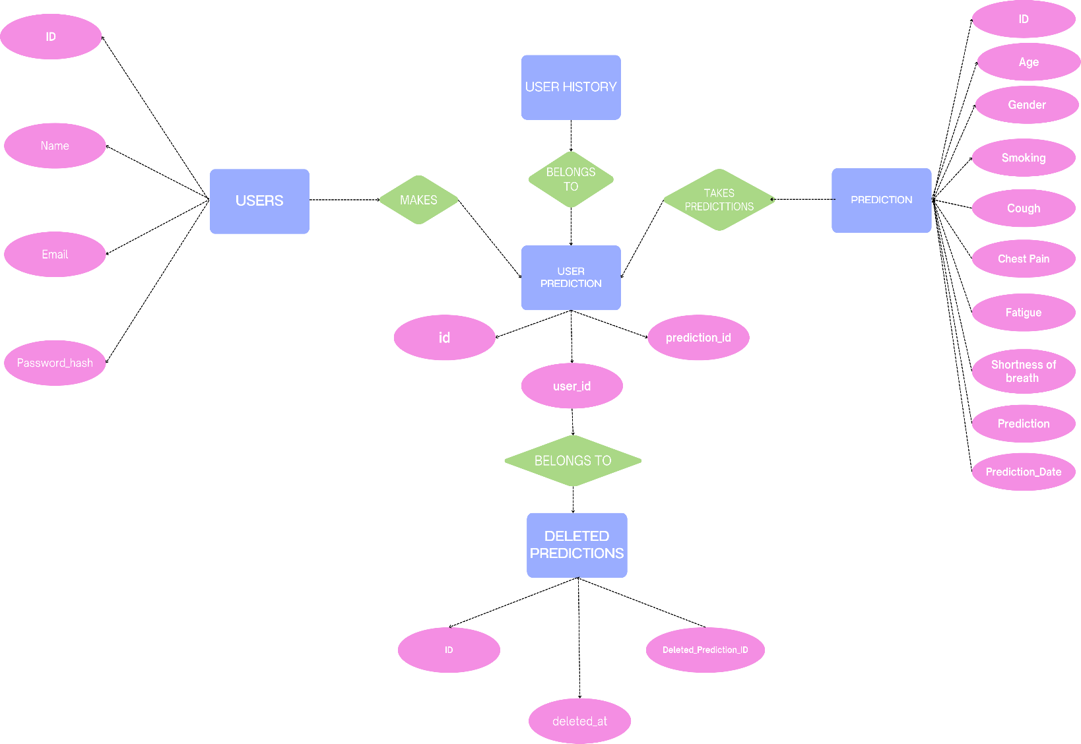

**CHAPTER-2**

**CONVERTING ER DIAGRAM TO RELATIONAL TABLE**

**USERS:**

|  |  |  |  |  |  |
| --- | --- | --- | --- | --- | --- |
| **User_ID (PK)** | **Name** | **Email** | **Password** | **Registration_Date** | **Last_Login** |

**MEDICAL_HISTORY:**

|  |  |  |  |  |  |
| --- | --- | --- | --- | --- | --- |
| **History_ID (PK)** | **User_ID (FK)** | **Family _History** | **Smoking _History** | **Previous _Diseases** | **Occupational _Exposure** |

**PREDICTIONS:**

|  |  |  |  |  |  |
| --- | --- | --- | --- | --- | --- |
| **Prediction_ID (PK)** | **User_ID (FK)** | **Risk_Score** | **Prediction_Date** | **Symptoms_List** | **Recommendations** |

**SYMPTOMS:**

|  |  |  |  |  |
| --- | --- | --- | --- | --- |
| **Symptom_ID (PK)** | **Symptom_Name** | **Severity_Level** | **Description** | **Category** |

**RECOMMENDATIONS:**

|  |  |  |  |  |
| --- | --- | --- | --- | --- |
| **Recommendation _ID (PK)** | **Risk _Level** | **Medical _Advice** | **Prevention _Tips** | **Follow_up_Steps** |

**USER_FEEDBACK:**

|  |  |  |  |  |  |
| --- | --- | --- | --- | --- | --- |
| **Feedback_ID (PK)** | **User_ID (FK)** | **Prediction_ID (FK)** | **Rating** | **Comments** | **Feedback _Date** |

**RISK_FACTORS:**

|  |  |  |  |  |
| --- | --- | --- | --- | --- |
| **Factor_ID (PK)** | **Factor_Name** | **Weight** | **Description** | **Category** |

**MEDICAL_REPORTS:**

|  |  |  |  |  |  |
| --- | --- | --- | --- | --- | --- |
| **Report_ID (PK)** | **User_ID (FK)** | **Report_Date** | **Report_Type** | **Findings** | **Doctor _Notes** |

**USER_SESSIONS:**

|  |  |  |  |  |
| --- | --- | --- | --- | --- |
| **Session_ID (PK)** | **User_ID (FK)** | **Login_Time** | **Logout_Time** | **IP_Address** |

**PREDICTION_HISTORY:**

|  |  |  |  |  |  |
| --- | --- | --- | --- | --- | --- |
| **History_ID (PK)** | **User_ID (FK)** | **Prediction_ID (FK)** | **Date** | **Risk_Score** | **Follow_up_Status** |

**PITFALLS OF RELATIONAL DATABASE SYSTEM:**

**1. Inadequate Normalization: Normalization is the process of organizing data into tables to minimize redundancy and eliminate data anomalies. Failure to normalize data can result in redundant patient information and update anomalies. This can lead to data inconsistencies and poor performance in medical record management.**

**2. Overuse of NULL values: Using NULL values in medical records can make it difficult to query patient data and can lead to confusion when interpreting medical histories. Overuse of NULL values can also result in poor performance in risk assessment calculations.**

**3. Poor Indexing: Indexing is essential for efficient querying of patient data and medical histories. Poorly designed indexes can result in slow query performance when retrieving patient records and risk assessments.**

**4. Insufficient Primary and Foreign Keys: Primary and foreign keys establish relationships between patient records, medical histories, and predictions. Failure to implement these keys can result in data inconsistencies and poor performance in tracking patient outcomes.**

**5. Denormalization: While denormalization can improve query performance for risk assessments, it can also lead to data inconsistencies in medical records and update anomalies. Denormalization should be used sparingly and only after careful consideration of medical data integrity.**

**6. Failure to Plan for Growth: A medical database should be designed with future growth in mind, considering increasing patient records and new risk factors. Failure to plan for growth can result in poor performance, data inconsistencies, and costly database redesigns.**

**7. Lack of Documentation: A lack of documentation can make it difficult to understand the database design and lead to errors in medical data analysis and risk assessment reporting. Proper documentation is crucial for maintaining accurate patient records and risk predictions.**

**8. Security Concerns: Medical data requires strict security measures. Failure to implement proper security protocols can lead to unauthorized access to sensitive patient information and risk assessment data.**

**9. Data Validation: Insufficient validation of medical data input can lead to incorrect risk assessments and compromised patient care. Proper validation rules must be implemented for all medical data fields.**

**10. Backup and Recovery: Regular backups of medical data are crucial. Failure to implement proper backup and recovery procedures can result in loss of critical patient information and risk assessment history.**

**CREATING TABLES IN THE DATABASE**

-- Table: Transaction Log

CREATE TABLE IF NOT EXISTS transaction_log (

id INT AUTO_INCREMENT PRIMARY KEY,

transaction_id VARCHAR(36) NOT NULL,

table_name VARCHAR(50) NOT NULL,

operation_type ENUM('INSERT', 'UPDATE', 'DELETE') NOT NULL,

record_id INT NOT NULL,

old_values JSON,

new_values JSON,

user_id INT,

timestamp TIMESTAMP DEFAULT CURRENT_TIMESTAMP,

status ENUM('COMMITTED', 'ROLLED_BACK', 'PENDING') DEFAULT 'PENDING'

);

-- Table: Version Control

CREATE TABLE IF NOT EXISTS version_control (

id INT AUTO_INCREMENT PRIMARY KEY,

table_name VARCHAR(50) NOT NULL,

record_id INT NOT NULL,

version_number INT NOT NULL DEFAULT 1,

last_modified TIMESTAMP DEFAULT CURRENT_TIMESTAMP ON UPDATE CURRENT_TIMESTAMP,

modified_by INT,

UNIQUE KEY (table_name, record_id)

);

-- Table: Lock Management

CREATE TABLE IF NOT EXISTS lock_management (

id INT AUTO_INCREMENT PRIMARY KEY,

table_name VARCHAR(50) NOT NULL,

record_id INT NOT NULL,

lock_type ENUM('SHARED', 'EXCLUSIVE') NOT NULL,

lock_holder INT NOT NULL,

lock_timestamp TIMESTAMP DEFAULT CURRENT_TIMESTAMP,

lock_timeout TIMESTAMP,

UNIQUE KEY (table_name, record_id)

);

-- Table: Users (for authentication)

CREATE TABLE IF NOT EXISTS users (

id INT AUTO_INCREMENT PRIMARY KEY,

name VARCHAR(100) NOT NULL,

email VARCHAR(100) UNIQUE NOT NULL,

password_hash VARCHAR(255) NOT NULL,

date_of_birth DATE,

created_at TIMESTAMP DEFAULT CURRENT_TIMESTAMP,

last_login TIMESTAMP NULL,

version INT DEFAULT 1

);

-- Table: User Medical History

CREATE TABLE IF NOT EXISTS medical_history (

id INT AUTO_INCREMENT PRIMARY KEY,

user_id INT NOT NULL,

family_history_of_cancer ENUM('yes', 'no', 'unknown') DEFAULT 'unknown',

years_smoking INT DEFAULT 0,

packs_per_day DECIMAL(3,1) DEFAULT 0.0,

previous_lung_diseases TEXT,

occupational_exposure ENUM('yes', 'no', 'unknown') DEFAULT 'unknown',

occupational_details TEXT,

updated_at TIMESTAMP DEFAULT CURRENT_TIMESTAMP ON UPDATE CURRENT_TIMESTAMP,

version INT DEFAULT 1,

FOREIGN KEY (user_id) REFERENCES users(id) ON DELETE CASCADE

);

-- Table: Symptoms (stores detailed symptom information)

CREATE TABLE IF NOT EXISTS symptoms (

id INT AUTO_INCREMENT PRIMARY KEY,

name VARCHAR(100) NOT NULL,

description TEXT,

severity_scale INT DEFAULT 3 COMMENT 'Scale from 1-5, with 5 being most severe',

related_to_lung_cancer BOOLEAN DEFAULT TRUE

);

-- Table: Predictions (stores user symptoms and prediction results)

CREATE TABLE IF NOT EXISTS predictions (

id INT AUTO_INCREMENT PRIMARY KEY,

age INT CHECK (age BETWEEN 0 AND 120),

gender ENUM('Male', 'Female', 'Other') NOT NULL,

smoking ENUM('yes', 'no') NOT NULL,

cough ENUM('yes', 'no') NOT NULL,

chest_pain ENUM('yes', 'no') NOT NULL,

fatigue ENUM('yes', 'no') NOT NULL,

shortness_of_breath ENUM('yes', 'no') NOT NULL,

prediction VARCHAR(255) NOT NULL,

risk_score DECIMAL(5,2) DEFAULT 0.0,

prediction_date TIMESTAMP DEFAULT CURRENT_TIMESTAMP,

version INT DEFAULT 1

);

-- Table: User Predictions (links users to their predictions)

CREATE TABLE IF NOT EXISTS user_predictions (

id INT AUTO_INCREMENT PRIMARY KEY,

user_id INT,

prediction_id INT,

notes TEXT,

FOREIGN KEY (user_id) REFERENCES users(id) ON DELETE CASCADE,

FOREIGN KEY (prediction_id) REFERENCES predictions(id) ON DELETE CASCADE

);

-- Table: Medical Recommendations

CREATE TABLE IF NOT EXISTS recommendations (

id INT AUTO_INCREMENT PRIMARY KEY,

risk_level ENUM('Low', 'Moderate', 'High') NOT NULL,

recommendation_text TEXT NOT NULL,

resource_links TEXT

);

-- Table: User Feedback (for system improvement)

CREATE TABLE IF NOT EXISTS user_feedback (

id INT AUTO_INCREMENT PRIMARY KEY,

user_id INT,

prediction_id INT,

feedback_text TEXT NOT NULL,

rating INT CHECK (rating BETWEEN 1 AND 5),

created_at TIMESTAMP DEFAULT CURRENT_TIMESTAMP,

FOREIGN KEY (user_id) REFERENCES users(id) ON DELETE SET NULL,

FOREIGN KEY (prediction_id) REFERENCES predictions(id) ON DELETE SET NULL

);

-- Table: Deleted Predictions Log

CREATE TABLE IF NOT EXISTS deleted_predictions_log (

id INT AUTO_INCREMENT PRIMARY KEY,

deleted_prediction_id INT,

deleted_at TIMESTAMP DEFAULT CURRENT_TIMESTAMP

);

# CHAPTER-3 QUERIES

Table: Transaction Log

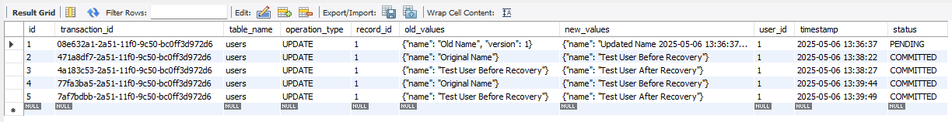

Table: Version Control

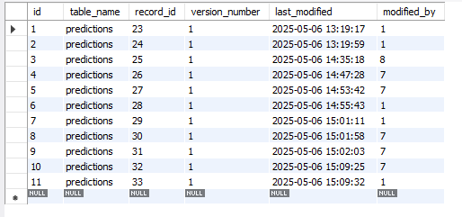

Table: Users

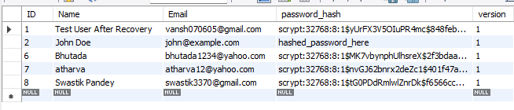

Table: medical_history

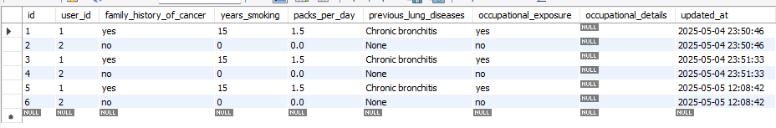

Table: Symptoms

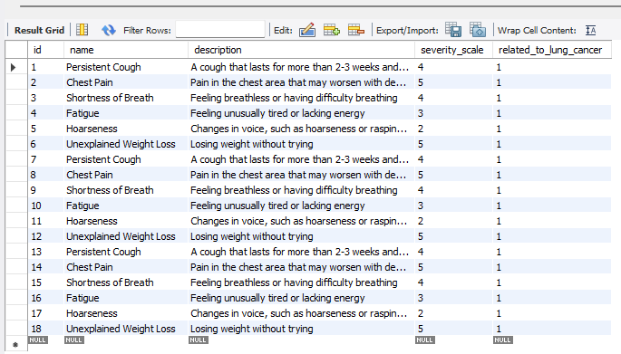

Table: predictions

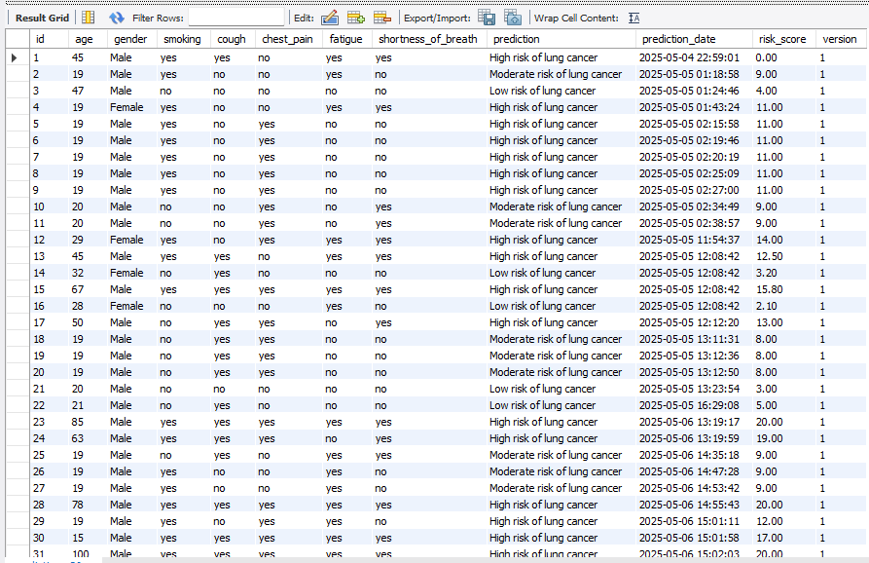

# CHAPTER -4 NORMALIZATION

# Normalization is the process to eliminate data redundancy and enhance data integrity in the table. Normalization also helps to organize the data in the database. It is a multi-step process that sets the data into tabular form and removes the duplicated data from the relational tables.

# TYPES OF NORMAL FORMS IN NORMALIZATION-

# 1. FIRST NORMAL FORM

# 2. SECOND NORMAL FORM

# 3. THIRD NORMAL FORM

# 4. BOYCE-CODD NORMAL FORM

# 5. FOURTH NORMAL FORM

# 6. FIFTH NORMAL FORM

# MEDICAL_HISTORY: 3NF

# Functional Dependency

# User_ID → Family_History, Smoking_History,Previous_Diseases, Occupational_Exposure

# History_ID →User_ID,Family_History,Smoking_History, Previous_Diseases, Occupational_Exposure

# User_ID → History_ID (transitive dependency)

# It is currently in 2NF because it has a transitive dependency of User_ID → History_ID. To convert it into 3NF, we need to remove the transitive dependency.

# TO CHANGE:

# 1. CREATE TABLE MEDICAL_HISTORY1 (

# History_ID VARCHAR2(20) PRIMARY KEY,

# User_ID VARCHAR2(20),

# Family_History VARCHAR2(100),

# Smoking_History VARCHAR2(100),

# Previous_Diseases VARCHAR2(100),

# Occupational_Exposure VARCHAR2(100)

# )

# 2. CREATE TABLE MEDICAL_HISTORY2 (

# User_ID VARCHAR2(20) PRIMARY KEY,

# History_ID VARCHAR2(20)

# )

# PREDICTIONS:

# NO NF

# Functional Dependency

# Prediction_ID → User_ID, Risk_Score, Prediction_Date, Symptoms_List, Recommendations

# Normalization

# There is atomicity in this table so we need to solve the multivalued attribute of Symptoms_List

# TO CHANGE:

# CREATE TABLE PREDICTIONS1 (

# Prediction_ID VARCHAR2(20),

# User_ID VARCHAR2(20),

# Risk_Score NUMBER,

# Prediction_Date DATE,

# Symptom1 VARCHAR2(50),

# Symptom2 VARCHAR2(50),

# Symptom3 VARCHAR2(50),

# Recommendations VARCHAR2(200)

# )

# 2NF

# Functional Dependency

# Prediction_ID → User_ID, Risk_Score, Prediction_Date, Symptom1, Symptom2, Symptom3, Recommendations

# User_ID → Risk_Score, Prediction_Date, Symptom1, Symptom2, Symptom3, Recommendations

# Normalization

# There is no Partial Primary key dependency, so this satisfies the condition for 2NF

# 3NF

# Functional Dependency

# Prediction_ID → User_ID, Risk_Score, Prediction_Date, Symptom1, Symptom2, Symptom3, Recommendations

# User_ID → Risk_Score, Prediction_Date, Symptom1, Symptom2, Symptom3, Recommendations

# Normalization

# There is no Transitive Dependency and every candidate key is a super key, so it satisfies Boyce-Codd and 4NF

# SYMPTOMS:

# 5NF

# Functional Dependency

# Symptom_ID → Symptom_Name, Severity_Level, Description, Category

# Category → Symptom_Name, Severity_Level, Description

# Normalization

# It's already existing in 3NF form, so no need to make any changes in the database.

# RECOMMENDATIONS:

# 5NF

# Functional Dependency

# Recommendation_ID → Risk_Level, Medical_Advice, Prevention_Tips, Follow_up_Steps

# Risk_Level → Medical_Advice, Prevention_Tips, Follow_up_Steps

# Normalization

# It's already existing in 3NF form, so no need to make any changes in the database.

# USER_FEEDBACK:

# 5NF

# Functional Dependency

# Feedback_ID → User_ID, Prediction_ID, Rating, Comments, Feedback_Date

# User_ID → Prediction_ID, Rating, Comments, Feedback_Date

# Normalization

# It's already existing in 3NF form, so no need to make any changes in the database.

# PITFALLS IN NORMALIZATION CONCEPT

While the provided data appears to be structured and normalized up to at least Second Normal Form (2NF), there are still potential pitfalls and areas for improvement in terms of database design and normalization concepts. Here are some pitfalls and considerations:

### Redundancy in Address and Contact Information:

- In several tables (e.g., User, Customer, ServiceProvider, Employee), there are columns for storing Address and ContactNumber. This can lead to redundancy if the same address or contact number needs to be updated in multiple places. One solution could be to create separate tables for Address and Contact information and link them using foreign keys.

### Denormalization for Performance:

While normalization helps in reducing redundancy and maintaining data integrity, in some cases, denormalization might be necessary for performance optimization. For example, in a high-transaction system, joining multiple tables frequently could impact performance. In such cases, carefully denormalizing certain tables or using materialized views can be considered.

### Potential Update Anomalies:

* + Update anomalies can occur when data needs to be updated in multiple places, leading to inconsistencies if not handled properly. For instance, if a customer's contact number changes, it needs to be updated in multiple tables (e.g., Customer, User) where it's stored, increasing the risk of inconsistencies.

### Lack of Data Validation:

* + Data validation is crucial to ensure data integrity. Without proper validation rules and constraints, the database may accept invalid or inconsistent data, leading to issues in data quality. Implementing data validation checks at the database level can mitigate this risk.

### Overly Nested Relationships:

* + While relationships between tables are necessary, overly nested relationships can make queries complex and impact performance. It's essential to strike a balance between maintaining relationships for data integrity and optimizing query performance.

### Incomplete Normalization:

* + Although the provided data seems to be normalized up to 2NF, further normalization (e.g., Third Normal Form - 3NF) could be beneficial in some cases. Analyzing functional dependencies and eliminating transitive dependencies can lead to a more robust and efficient database design.

### Handling Historical Data:

* + If historical data tracking is required (e.g., tracking changes in meter readings over time), additional considerations for data storage and retrieval mechanisms may be needed. Implementing effective techniques such as versioning or audit trails can address this requirement without compromising normalization.

### Optimizing Indexing and Query Performance:

* + While normalization focuses on data organization, indexing and optimizing queries are essential for efficient data retrieval. Proper indexing strategies, query optimization techniques,and understanding the database engine's capabilities are crucial for improving overall system performance.

Addressing these pitfalls involves a combination of thoughtful database design, adherence to normalization principles, implementing data validation rules, optimizing performance, and considering specific business requirements for data storage and retrieval.

**CHAPTER-5**

## Implementation of concurrency control and recovery mechanisms

## 1. Concurrency Control Mechanisms:

## a) Lock Management:

## - Implements a global locking mechanism to ensure only one user can make a prediction at a time

## - Prevents race conditions during risk assessment calculations

## - Ensures data consistency in medical records

## - Lock types:

## * Shared locks for reading patient data

## * Exclusive locks for updating medical histories

## * Prediction locks for risk assessment calculations

## b) Version Control:

## - Maintains version history of medical records

## - Tracks changes to risk assessments

## - Prevents lost updates in patient data

## - Supports optimistic concurrency control

## c) Transaction Management:

## - Ensures atomicity of medical data updates

## - Maintains consistency in risk assessment calculations

## - Isolates concurrent user sessions

## - Provides durability for medical records

## 2. Recovery Mechanisms:

## a) Transaction Log:

## - Records all changes to medical data

## - Tracks risk assessment calculations

## - Maintains audit trail of patient interactions

## - Enables point-in-time recovery

## b) Backup Procedures:

## - Daily full backups of medical database

## - Incremental backups every 6 hours

## - Backup of risk assessment models

## - Secure storage of patient data

## c) Recovery Procedures:

## - Point-in-time recovery for medical records

## - Crash recovery for interrupted predictions

## - System state recovery

## - Data consistency checks

## 3. Implementation Details:

## a) Lock Implementation:

## b) Lock Acquisition Procedures:

## 

## c) Lock Release Procedures:

## 

#### TRANSACTION FAILURE

#### TRANSACTION FAILURE HANDLING

#### 1. Types of Transaction Failures:

#### a) System Failures:

#### - Database crashes during risk assessment

#### - Server power failures

#### - Network interruptions

#### - Memory overflow during prediction calculations

#### b) Transaction Failures:

#### - Deadlocks during concurrent predictions

#### - Timeout during medical history updates

#### - Validation errors in risk assessment data

#### - Constraint violations in patient records

#### 2. Recovery Mechanisms:

#### ```sql

#### -- Transaction Log Table

#### CREATE TABLE transaction_log (

#### id INT AUTO_INCREMENT PRIMARY KEY,

#### transaction_id VARCHAR(36) NOT NULL,

#### table_name VARCHAR(50) NOT NULL,

#### operation_type ENUM('INSERT', 'UPDATE', 'DELETE') NOT NULL,

#### record_id INT NOT NULL,

#### old_values JSON,

#### new_values JSON,

#### user_id INT,

#### timestamp TIMESTAMP DEFAULT CURRENT_TIMESTAMP,

#### status ENUM('COMMITTED', 'ROLLED_BACK', 'PENDING') DEFAULT 'PENDING'

#### );

#### -- Recovery Procedure

#### DELIMITER $$

#### CREATE PROCEDURE handle_transaction_failure(

#### IN p_transaction_id VARCHAR(36)

#### )

#### BEGIN

#### -- Log the failure

#### INSERT INTO transaction_log

#### (transaction_id, table_name, operation_type, record_id, status)

#### VALUES (p_transaction_id, 'predictions', 'FAILED', 0, 'ROLLED_BACK');

#### 

#### -- Rollback any pending changes

#### ROLLBACK;

#### 

#### -- Release any held locks

#### DELETE FROM lock_management

#### WHERE lock_holder = (SELECT user_id FROM transaction_log

#### WHERE transaction_id = p_transaction_id);

#### END $$

#### DELIMITER ;

#### ```

#### 3. Error Handling:

#### ```sql

#### -- Error Log Table

#### CREATE TABLE error_log (

#### id INT AUTO_INCREMENT PRIMARY KEY,

#### error_type VARCHAR(50) NOT NULL,

#### error_message TEXT,

#### transaction_id VARCHAR(36),

#### timestamp TIMESTAMP DEFAULT CURRENT_TIMESTAMP,

#### severity ENUM('LOW', 'MEDIUM', 'HIGH') DEFAULT 'MEDIUM'

#### );

#### -- Error Handling Procedure

#### DELIMITER $$

#### CREATE PROCEDURE log_transaction_error(

#### IN p_error_type VARCHAR(50),

#### IN p_error_message TEXT,

#### IN p_transaction_id VARCHAR(36),

#### IN p_severity ENUM('LOW', 'MEDIUM', 'HIGH')

#### )

#### BEGIN

#### -- Log the error

#### INSERT INTO error_log

#### (error_type, error_message, transaction_id, severity)

#### VALUES (p_error_type, p_error_message, p_transaction_id, p_severity);

#### 

#### -- Handle based on severity

#### CASE p_severity

#### WHEN 'HIGH' THEN

#### -- Notify administrators

#### CALL notify_admin(p_error_message);

#### -- Rollback transaction

#### CALL handle_transaction_failure(p_transaction_id);

#### WHEN 'MEDIUM' THEN

#### -- Log and continue

#### UPDATE transaction_log

#### SET status = 'PENDING'

#### WHERE transaction_id = p_transaction_id;

#### WHEN 'LOW' THEN

#### -- Just log the error

#### UPDATE transaction_log

#### SET status = 'COMMITTED'

#### WHERE transaction_id = p_transaction_id;

#### END CASE;

#### END $$

#### DELIMITER ;

#### ```

#### 4. Recovery Steps:

#### a) For System Failures:

#### - Check transaction log for incomplete transactions

#### - Restore database from last backup

#### - Replay committed transactions

#### - Verify data consistency

#### b) For Transaction Failures:

#### - Identify failed transaction

#### - Rollback incomplete changes

#### - Release held locks

#### - Log failure details

#### - Notify affected users

#### 5. Prevention Measures:

#### a) Before Transaction:

#### - Validate input data

#### - Check system resources

#### - Verify user permissions

#### - Ensure data consistency

#### b) During Transaction:

#### - Monitor transaction progress

#### - Track resource usage

#### - Maintain lock timeouts

#### - Log all operations

#### c) After Transaction:

#### - Verify data integrity

#### - Update transaction status

#### - Release resources

#### - Log completion

#### The system maintains data integrity and provides clear feedback to users when transaction failures occur.

#### DEADLOCK PREVENTION

#### 

**SET innodb_lock_wait_timeout = 10;: This line sets the timeout period for InnoDB lock waits to 10 seconds. InnoDB is a storage engine for MySQL that provides transaction support.**

**START TRANSACTION;: Begins a new transaction.**

**SELECT * FROM medical_history WHERE user_id = 'U123' FOR UPDATE;: This line selects data from the medical_history table for the user with ID 'U123' and locks the selected rows with a "FOR UPDATE" clause. This locking ensures that other transactions cannot modify these rows until the current transaction is completed.**

**INSERT INTO transaction_log;: This line inserts a record into the transaction_log table, recording information about an update operation (in this case, updating the medical history with new smoking history and lung disease information).**

**COMMIT;: Commits the transaction, making all changes permanent if all statements within the transaction execute successfully.**

### Recovery Mechanism:

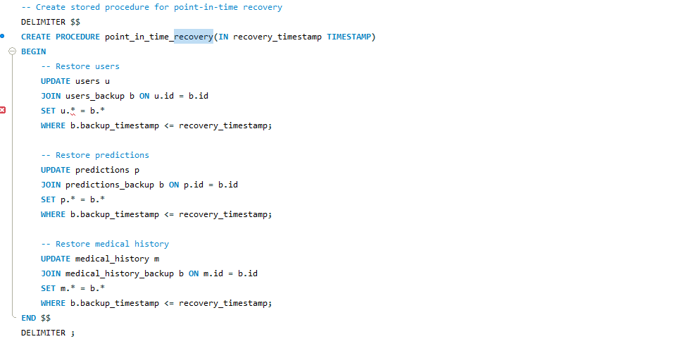

1. Transaction Logging:

- Maintains a detailed record of all database changes

- Records medical history updates, risk assessments, and patient data modifications

- Stores both old and new values for each change

- Enables point-in-time recovery of medical records

2. Backup Procedures:

- Daily full backups of the medical database

- Incremental backups every 6 hours

- Secure storage of patient data and risk assessment models

- Backup of critical medical history and prediction data

3. Point-in-Time Recovery:

- Allows restoration of medical data to any specific point in time

- Useful for recovering from data corruption or incorrect updates

- Maintains data consistency across all medical records

- Preserves the integrity of risk assessment history

4. Crash Recovery:

- Automatically recovers from system failures

- Restores medical data to a consistent state

- Handles interrupted risk assessment calculations

- Maintains transaction atomicity

5. Implementation Example:

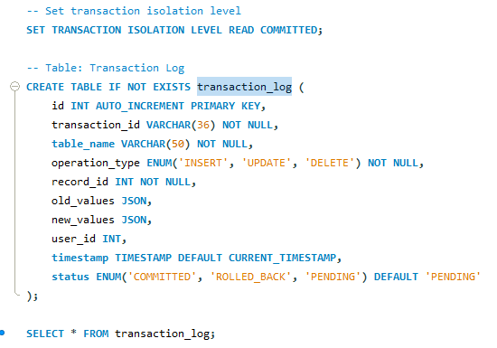

-- Point-in-Time Recovery Procedure

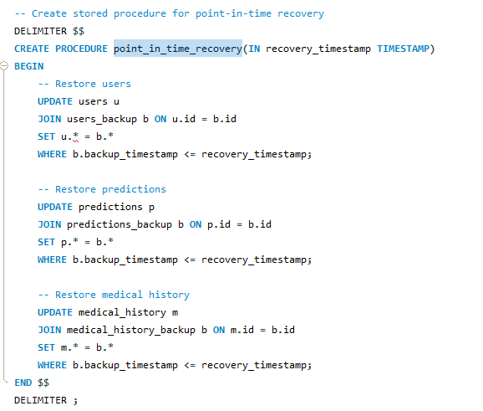

6. Recovery Steps:

a) System Failure Recovery:

- Check transaction log for incomplete transactions

- Restore database from last backup

- Replay committed transactions

- Verify medical data consistency

b) Data Corruption Recovery:

- Identify corrupted medical records

- Restore from backup

- Verify data integrity

- Update transaction logs

c) User Error Recovery:

- Identify incorrect updates

- Restore affected records

- Maintain audit trail

- Notify affected users

7. Security Measures:

- Encrypt backup files

- Secure transaction logs

- Implement access controls

- Maintain audit trails

8. Performance Considerations:

- Optimize backup procedures

- Manage storage efficiently

- Implement parallel recovery

- Monitor recovery times

This implementation ensures:

1. Data consistency in medical records

2. Reliable risk assessment history

3. Secure patient data management

4. Efficient recovery procedures

5. Comprehensive audit trailing

6. System availability

7. Data integrity protection

8. Patient safety

The system maintains:

- Medical data accuracy

- Risk assessment reliability

- Patient record integrity

- System stability

- Data security

- Recovery efficiency

- Audit compliance

- Healthcare standardsstatements will be treated as part of a single unit of work. Transactions ensure data consistency by allowing a series of operations to be either committed (saved permanently) or rolled back (reverted) as a whole.

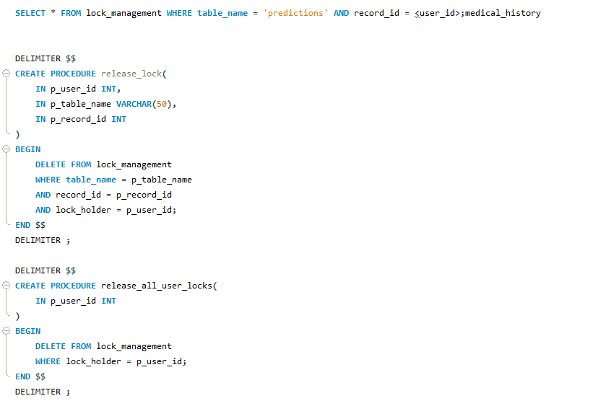

**CHAPTER-6 CODE FOR THE PROJECT**

## SQL CODE:

*-- Create the database*

CREATE DATABASE IF NOT EXISTS lung_cancer_db;

USE lung_cancer_db;

*-- Set transaction isolation level*

SET TRANSACTION ISOLATION LEVEL READ COMMITTED;

*-- Table: Transaction Log*

CREATE TABLE IF NOT EXISTS transaction_log (

    id INT AUTO_INCREMENT PRIMARY KEY,

    transaction_id VARCHAR(36) NOT NULL,

    table_name VARCHAR(50) NOT NULL,

    operation_type ENUM('INSERT', 'UPDATE', 'DELETE') NOT NULL,

    record_id INT NOT NULL,

    old_values JSON,

    new_values JSON,

    user_id INT,

    timestamp TIMESTAMP DEFAULT CURRENT_TIMESTAMP,

    status ENUM('COMMITTED', 'ROLLED_BACK', 'PENDING') DEFAULT 'PENDING'

);

*-- Table: Version Control*

CREATE TABLE IF NOT EXISTS version_control (

    id INT AUTO_INCREMENT PRIMARY KEY,

    table_name VARCHAR(50) NOT NULL,

    record_id INT NOT NULL,

    version_number INT NOT NULL DEFAULT 1,

    last_modified TIMESTAMP DEFAULT CURRENT_TIMESTAMP ON UPDATE CURRENT_TIMESTAMP,

    modified_by INT,

    UNIQUE KEY (table_name, record_id)

);

*-- Table: Lock Management*

CREATE TABLE IF NOT EXISTS lock_management (

    id INT AUTO_INCREMENT PRIMARY KEY,

    table_name VARCHAR(50) NOT NULL,

    record_id INT NOT NULL,

    lock_type ENUM('SHARED', 'EXCLUSIVE') NOT NULL,

    lock_holder INT NOT NULL,

    lock_timestamp TIMESTAMP DEFAULT CURRENT_TIMESTAMP,

    lock_timeout TIMESTAMP,

    UNIQUE KEY (table_name, record_id)

);

*-- Table: Users (for authentication)*

CREATE TABLE IF NOT EXISTS users (

    id INT AUTO_INCREMENT PRIMARY KEY,

    name VARCHAR(100) NOT NULL,

    email VARCHAR(100) UNIQUE NOT NULL,

    password_hash VARCHAR(255) NOT NULL,

    date_of_birth DATE,

    created_at TIMESTAMP DEFAULT CURRENT_TIMESTAMP,

    last_login TIMESTAMP NULL,

    version INT DEFAULT 1

);

*-- Table: User Medical History*

CREATE TABLE IF NOT EXISTS medical_history (

    id INT AUTO_INCREMENT PRIMARY KEY,

    user_id INT NOT NULL,

    family_history_of_cancer ENUM('yes', 'no', 'unknown') DEFAULT 'unknown',

    years_smoking INT DEFAULT 0,

    packs_per_day DECIMAL(3,1) DEFAULT 0.0,

    previous_lung_diseases TEXT,

    occupational_exposure ENUM('yes', 'no', 'unknown') DEFAULT 'unknown',

    occupational_details TEXT,

    updated_at TIMESTAMP DEFAULT CURRENT_TIMESTAMP ON UPDATE CURRENT_TIMESTAMP,

    version INT DEFAULT 1,

    FOREIGN KEY (user_id) REFERENCES users(id) ON DELETE CASCADE

);

*-- Table: Symptoms (stores detailed symptom information)*

CREATE TABLE IF NOT EXISTS symptoms (

    id INT AUTO_INCREMENT PRIMARY KEY,

    name VARCHAR(100) NOT NULL,

    description TEXT,

    severity_scale INT DEFAULT 3 COMMENT 'Scale from 1-5, with 5 being most severe',

    related_to_lung_cancer BOOLEAN DEFAULT TRUE

);

*-- Table: Predictions (stores user symptoms and prediction results)*

CREATE TABLE IF NOT EXISTS predictions (

    id INT AUTO_INCREMENT PRIMARY KEY,

    age INT CHECK (age BETWEEN 0 AND 120),

    gender ENUM('Male', 'Female', 'Other') NOT NULL,

    smoking ENUM('yes', 'no') NOT NULL,

    cough ENUM('yes', 'no') NOT NULL,

    chest_pain ENUM('yes', 'no') NOT NULL,

    fatigue ENUM('yes', 'no') NOT NULL,

    shortness_of_breath ENUM('yes', 'no') NOT NULL,

    prediction VARCHAR(255) NOT NULL,

    risk_score DECIMAL(5,2) DEFAULT 0.0,

    prediction_date TIMESTAMP DEFAULT CURRENT_TIMESTAMP,

    version INT DEFAULT 1

);

*-- Table: User Predictions (links users to their predictions)*

CREATE TABLE IF NOT EXISTS user_predictions (

    id INT AUTO_INCREMENT PRIMARY KEY,

    user_id INT,

    prediction_id INT,

    notes TEXT,

    FOREIGN KEY (user_id) REFERENCES users(id) ON DELETE CASCADE,

    FOREIGN KEY (prediction_id) REFERENCES predictions(id) ON DELETE CASCADE

);

*-- Table: Medical Recommendations*

CREATE TABLE IF NOT EXISTS recommendations (

    id INT AUTO_INCREMENT PRIMARY KEY,

    risk_level ENUM('Low', 'Moderate', 'High') NOT NULL,

    recommendation_text TEXT NOT NULL,

    resource_links TEXT

);

*-- Table: User Feedback (for system improvement)*

CREATE TABLE IF NOT EXISTS user_feedback (

    id INT AUTO_INCREMENT PRIMARY KEY,

    user_id INT,

    prediction_id INT,

    feedback_text TEXT NOT NULL,

    rating INT CHECK (rating BETWEEN 1 AND 5),

    created_at TIMESTAMP DEFAULT CURRENT_TIMESTAMP,

    FOREIGN KEY (user_id) REFERENCES users(id) ON DELETE SET NULL,

    FOREIGN KEY (prediction_id) REFERENCES predictions(id) ON DELETE SET NULL

);

*-- Table: Deleted Predictions Log*

CREATE TABLE IF NOT EXISTS deleted_predictions_log (

    id INT AUTO_INCREMENT PRIMARY KEY,

    deleted_prediction_id INT,

    deleted_at TIMESTAMP DEFAULT CURRENT_TIMESTAMP

);

*-- Create backup table for critical data*

CREATE TABLE IF NOT EXISTS users_backup LIKE users;

CREATE TABLE IF NOT EXISTS predictions_backup LIKE predictions;

CREATE TABLE IF NOT EXISTS medical_history_backup LIKE medical_history;

*-- Create stored procedure for backup*

DELIMITER $$

CREATE PROCEDURE create_backup()

BEGIN

    DECLARE backup_timestamp TIMESTAMP;

    SET backup_timestamp = CURRENT_TIMESTAMP;

*-- Backup users*

    INSERT INTO users_backup

    SELECT *, backup_timestamp FROM users;

*-- Backup predictions*

    INSERT INTO predictions_backup

    SELECT *, backup_timestamp FROM predictions;

*-- Backup medical history*

    INSERT INTO medical_history_backup

    SELECT *, backup_timestamp FROM medical_history;

END $$

DELIMITER ;

*-- Create stored procedure for point-in-time recovery*

DELIMITER $$

CREATE PROCEDURE point_in_time_recovery(IN recovery_timestamp TIMESTAMP)

BEGIN

*-- Restore users*

    UPDATE users u

    JOIN users_backup b ON u.id = b.id

    SET u.* = b.*

    WHERE b.backup_timestamp <= recovery_timestamp;

*-- Restore predictions*

    UPDATE predictions p

    JOIN predictions_backup b ON p.id = b.id

    SET p.* = b.*

    WHERE b.backup_timestamp <= recovery_timestamp;

*-- Restore medical history*

    UPDATE medical_history m

    JOIN medical_history_backup b ON m.id = b.id

    SET m.* = b.*

    WHERE b.backup_timestamp <= recovery_timestamp;

END $$

DELIMITER ;

*-- Create trigger for transaction logging*

DELIMITER $$

CREATE TRIGGER log_user_changes

AFTER UPDATE ON users

FOR EACH ROW

BEGIN

    INSERT INTO transaction_log (transaction_id, table_name, operation_type, record_id, old_values, new_values)

    VALUES (

        UUID(),

        'users',

        'UPDATE',

        NEW.id,

        JSON_OBJECT(

            'name', OLD.name,

            'email', OLD.email,

            'version', OLD.version

        ),

        JSON_OBJECT(

            'name', NEW.name,

            'email', NEW.email,

            'version', NEW.version

        )

    );

END $$

DELIMITER ;

*-- Create stored procedure for deadlock detection*

DELIMITER $$

CREATE PROCEDURE detect_deadlocks()

BEGIN

    DECLARE done INT DEFAULT 0;

    DECLARE lock_id INT;

    DECLARE cur CURSOR FOR

        SELECT id FROM lock_management

        WHERE lock_timeout < CURRENT_TIMESTAMP;

    DECLARE CONTINUE HANDLER FOR NOT FOUND SET done = 1;

    OPEN cur;

    read_loop: LOOP

        FETCH cur INTO lock_id;

        IF done THEN

            LEAVE read_loop;

        END IF;

*-- Release expired locks*

        DELETE FROM lock_management WHERE id = lock_id;

    END LOOP;

    CLOSE cur;

END $$

DELIMITER ;

*-- Create event scheduler for regular maintenance*

CREATE EVENT IF NOT EXISTS maintenance_schedule

ON SCHEDULE EVERY 1 DAY

DO

BEGIN

*-- Create daily backup*

    CALL create_backup();

*-- Clean up old transaction logs (keep last 30 days)*

    DELETE FROM transaction_log

    WHERE timestamp < DATE_SUB(CURRENT_TIMESTAMP, INTERVAL 30 DAY);

*-- Check for deadlocks*

    CALL detect_deadlocks();

END;

*-- Enable event scheduler*

SET GLOBAL event_scheduler = ON;

*-- Insert sample data for testing*

*-- Users*

*-- INSERT INTO users (name, email, password_hash, date_of_birth)*

*-- VALUES*

*-- ('John Doe', 'john@example.com', '$2b$12$ILv4xGHgz0DzFOEI8WtCre6GX6KtSQa/D1Yyz7.TqVw9AYyRlGK6y', '1980-05-15'),  -- Password: password123*

*-- ('Jane Smith', 'jane@example.com', '$2b$12$ILv4xGHgz0DzFOEI8WtCre6GX6KtSQa/D1Yyz7.TqVw9AYyRlGK6y', '1992-03-21');*

*-- Medical History*

*-- INSERT INTO medical_history (user_id, family_history_of_cancer, years_smoking, packs_per_day, previous_lung_diseases, occupational_exposure)*

*-- VALUES*

*-- (1, 'yes', 15, 1.5, 'Chronic bronchitis', 'yes'),*

*-- (2, 'no', 0, 0.0, 'None', 'no');*

*-- Symptoms*

*-- INSERT INTO symptoms (name, description, severity_scale, related_to_lung_cancer)*

*-- VALUES*

*-- ('Persistent Cough', 'A cough that lasts for more than 2-3 weeks and doesn\'t improve', 4, TRUE),*

*-- ('Chest Pain', 'Pain in the chest area that may worsen with deep breathing or coughing', 5, TRUE),*

*-- ('Shortness of Breath', 'Feeling breathless or having difficulty breathing', 4, TRUE),*

*-- ('Fatigue', 'Feeling unusually tired or lacking energy', 3, TRUE),*

*-- ('Hoarseness', 'Changes in voice, such as hoarseness or raspiness', 2, TRUE),*

*-- ('Unexplained Weight Loss', 'Losing weight without trying', 5, TRUE);*

*-- Predictions*

*-- INSERT INTO predictions (age, gender, smoking, cough, chest_pain, fatigue, shortness_of_breath, prediction, risk_score)*

*-- VALUES*

*-- (45, 'Male', 'yes', 'yes', 'no', 'yes', 'yes', 'High risk of lung cancer', 12.5),*

*-- (32, 'Female', 'no', 'yes', 'no', 'no', 'no', 'Low risk of lung cancer', 3.2),*

*-- (67, 'Male', 'yes', 'yes', 'yes', 'yes', 'yes', 'High risk of lung cancer', 15.8),*

*-- (28, 'Female', 'no', 'no', 'no', 'yes', 'no', 'Low risk of lung cancer', 2.1);*

*-- Link users to predictions*

*-- INSERT INTO user_predictions (user_id, prediction_id, notes)*

*-- VALUES*

*-- (1, 1, 'Initial assessment after developing cough'),*

*-- (1, 3, 'Follow-up after chest pain developed'),*

*-- (2, 2, 'Routine checkup');*

*-- Recommendations*

*-- INSERT INTO recommendations (risk_level, recommendation_text, resource_links)*

*-- VALUES*

*-- ('Low', 'Maintain a healthy lifestyle. If you smoke, consider quitting. Schedule regular check-ups with your doctor.', 'https://www.cancer.org/healthy/stay-away-from-tobacco.html'),*

*-- ('Moderate', 'Schedule an appointment with your doctor to discuss your symptoms. Consider a chest X-ray or CT scan for further evaluation.', 'https://www.cancer.org/cancer/lung-cancer/detection-diagnosis-staging.html'),*

*-- ('High', 'Contact your doctor immediately to schedule comprehensive testing. This may include imaging tests and possibly a biopsy.', 'https://www.cancer.org/cancer/lung-cancer/treating.html');*

*-- User Feedback*

*-- INSERT INTO user_feedback (user_id, prediction_id, feedback_text, rating)*

*-- VALUES*

*-- (1, 1, 'The assessment was helpful and matched what my doctor told me.', 5),*

*-- (2, 2, 'I would have liked more detailed recommendations.', 3);*

SELECT * from users;

SELECT * FROM user_predictions;

SHOW TABLES;

DROP TABLE IF EXISTS user_prediction;

DROP TABLE IF EXISTS prediction;

DROP TABLE IF EXISTS deleted_predictions;

CREATE OR REPLACE VIEW user_prediction_history AS

SELECT

    u.id AS user_id,

    u.name AS user_name,

    u.email AS user_email,

    p.id AS prediction_id,

    p.age, p.gender, p.smoking, p.cough, p.chest_pain, p.fatigue, p.shortness_of_breath,

    p.prediction, p.risk_score, p.prediction_date

FROM users u

JOIN user_predictions up ON u.id = up.user_id

JOIN predictions p ON up.prediction_id = p.id

ORDER BY p.prediction_date DESC;

DELIMITER $$

CREATE TRIGGER after_prediction_delete

AFTER DELETE ON predictions

FOR EACH ROW

BEGIN

    INSERT INTO deleted_predictions_log (deleted_prediction_id) VALUES (OLD.id);

END $$

DELIMITER ;

DELIMITER $$

CREATE PROCEDURE update_all_risk_scores()

BEGIN

    DECLARE done INT DEFAULT 0;

    DECLARE pred_id INT;

    DECLARE cur CURSOR FOR SELECT id FROM predictions;

    DECLARE CONTINUE HANDLER FOR NOT FOUND SET done = 1;

    OPEN cur;

    read_loop: LOOP

        FETCH cur INTO pred_id;

        IF done THEN

            LEAVE read_loop;

        END IF;

*-- Example: set risk_score to 0 for demonstration*

        UPDATE predictions SET risk_score = 0 WHERE id = pred_id;

    END LOOP;

    CLOSE cur;

END $$

DELIMITER ;

SELECT * FROM lock_management;

SELECT * FROM lock_management WHERE table_name = 'predictions' AND record_id = <user_id>;

## Employee_Adding:

package rest;

import java.awt.EventQueue;

import javax.swing.JFrame; import javax.swing.JLabel; import java.awt.Font;

import java.awt.event.ActionEvent; import java.awt.event.ActionListener; import java.sql.Connection;

import java.sql.DriverManager; import java.sql.PreparedStatement; import java.util.Scanner;

import javax.swing.JTextField; import javax.swing.JButton;

public class Employee_add { String field1,field3,field4; int field2;

JFrame frame2;

private JTextField textField; private JTextField textField_1; private JTextField textField_2; private JTextField textField_3;

public static void main(String[] args) { EventQueue.invokeLater(new Runnable() {

public void run() { try {

Employee_add window = new Employee_add(); window.frame2.setVisible(true);

} catch (Exception e) {

e.printStackTrace();

}

}

});

}

public Employee_add() { initialize();

}

private void initialize() {

frame2 = new JFrame(); frame2.setBounds(100, 100, 450, 300);

frame2.setDefaultCloseOperation(JFrame.EXIT_ON_CLOSE); frame2.getContentPane().setLayout(null);

JLabel lblNewLabel = new JLabel("Gender");

lblNewLabel.setFont(new Font("Tahoma", Font.PLAIN, 15)); lblNewLabel.setBounds(30, 29, 98, 38); frame2.getContentPane().add(lblNewLabel);

JLabel lblSalary = new JLabel("Salary"); lblSalary.setFont(new Font("Tahoma", Font.PLAIN, 15)); lblSalary.setBounds(30, 77, 98, 38); frame2.getContentPane().add(lblSalary);

JLabel lblName = new JLabel("Name"); lblName.setFont(new Font("Tahoma", Font.PLAIN, 15)); lblName.setBounds(30, 125, 98, 38); frame2.getContentPane().add(lblName);

JLabel lblEmployeeid = new JLabel("Employee_ID"); lblEmployeeid.setFont(new Font("Tahoma", Font.PLAIN, 14)); lblEmployeeid.setBounds(30, 173, 98, 38); frame2.getContentPane().add(lblEmployeeid);

textField = new JTextField(); textField.setBounds(160, 29, 145, 29); frame2.getContentPane().add(textField); textField.setColumns(10);

textField_1 = new JTextField(); textField_1.setColumns(10); textField_1.setBounds(160, 77, 145, 29); frame2.getContentPane().add(textField_1);

textField_2 = new JTextField(); textField_2.setColumns(10); textField_2.setBounds(160, 125, 145, 29); frame2.getContentPane().add(textField_2);

textField_3 = new JTextField(); textField_3.setColumns(10); textField_3.setBounds(160, 180, 145, 29); frame2.getContentPane().add(textField_3);

JButton btnNewButton = new JButton("Next"); btnNewButton.setFont(new Font("Tahoma", Font.PLAIN, 15)); btnNewButton.setBounds(297, 219, 109, 34); btnNewButton.addActionListener(new ActionListener() {

public void actionPerformed(ActionEvent e) { try {

Connection con = DriverManager.getConnection("jdbc:mysql://localhost:3306/restaurant", "root", "teamosekire");

Scanner scan=new Scanner(System.in); field1=textField.getText();

field2=Integer.parseInt(textField_1.getText()); field3=textField_2.getText(); field4=textField_3.getText();

String mini="insert into Employee values(?,?,?,?)"; PreparedStatement s3= con.prepareStatement(mini); s3.setString(1,field1);

s3.setInt(2, field2); s3.setString(3, field3); s3.setString(4, field4); s3.executeUpdate(); s3.close();

con.close();

Employee_D obj = new Employee_D(); obj.frame1.setVisible(true); frame2.dispose();

} catch (Exception e1) {

System.out.println(e1.getMessage());

}

}

});

frame2.getContentPane().add(btnNewButton);

}

}

## Employee Display:

package rest;

import java.awt.BorderLayout; import java.awt.Container; import java.awt.EventQueue;

import java.awt.event.ActionEvent; import java.awt.event.ActionListener; import java.sql.Connection;

import java.sql.DriverManager; import java.sql.PreparedStatement; import java.sql.ResultSet;

import javax.swing.JButton; import javax.swing.JFrame; import javax.swing.JScrollPane; import javax.swing.JTable;

import javax.swing.table.DefaultTableModel;

public class Employee_D {

JFrame frame1; private JTable jtbl;

private DefaultTableModel model;

/**

* Launch the application.

*/

public static void main(String[] args) { EventQueue.invokeLater(new Runnable() {

public void run() { try {

Employee_D window = new Employee_D(); window.frame1.setVisible(true);

} catch (Exception e) {

e.printStackTrace();

}

}

});

}

/**

* Create the application.

*/

public Employee_D() {

initialize();

}

/**

* Initialize the contents of the frame.

*/

private void initialize() {

frame1 = new JFrame(); frame1.setBounds(100, 100, 450, 300);

frame1.setDefaultCloseOperation(JFrame.EXIT_ON_CLOSE);

model = new DefaultTableModel(); model.addColumn("Name"); model.addColumn("Gender"); model.addColumn("Salary"); model.addColumn("Employee_id");

jtbl = new JTable(model); frame1.getContentPane().setLayout(new BorderLayout());

frame1.getContentPane().add(new JScrollPane(jtbl), BorderLayout.CENTER);

JButton btnLoadData = new JButton("Back"); btnLoadData.addActionListener(new ActionListener() {

public void actionPerformed(ActionEvent e) { MainPage1 obj = new MainPage1(); obj.frame.setVisible(true); frame1.dispose();

}

});

frame1.getContentPane().add(btnLoadData, BorderLayout.SOUTH); try {

Class.forName("com.mysql.cj.jdbc.Driver"); Connection con =

DriverManager.getConnection("jdbc:mysql://localhost:3306/restaurant", "root", "teamosekire");

String query = "SELECT * FROM employee"; PreparedStatement s1 = con.prepareStatement(query); ResultSet rs = s1.executeQuery();

while (rs.next()) {

model.addRow(new Object[]{rs.getString("Name"), rs.getString("Gender"), rs.getString("Salary"), rs.getString("Employee_id")});

}

con.close();

s1.close();

rs.close();

} catch (Exception e) {

System.out.println(e.getMessage());

}

frame1.pack();

}

}

## Menu Display:

package rest;

import java.awt.BorderLayout; import java.awt.EventQueue; import java.awt.event.ActionEvent;

import java.awt.event.ActionListener; import java.sql.Connection;

import java.sql.DriverManager; import java.sql.PreparedStatement; import java.sql.ResultSet;

import javax.swing.JButton; import javax.swing.JFrame; import javax.swing.JScrollPane; import javax.swing.JTable;

import javax.swing.table.DefaultTableModel; public class Menu {

JFrame frame1;

private JTable jtbl;

private DefaultTableModel model;

public static void main(String[] args) { EventQueue.invokeLater(new Runnable() {

public void run() { try {

Menu window = new Menu(); window.frame1.setVisible(true);

} catch (Exception e) {

e.printStackTrace();

}

}

});

}

public Menu() {

initialize();

}

private void initialize() {

frame1 = new JFrame(); frame1.setBounds(100, 100, 450, 300);

frame1.setDefaultCloseOperation(JFrame.EXIT_ON_CLOSE);

model = new DefaultTableModel(); model.addColumn("Timing"); model.addColumn("Cuisine"); model.addColumn("Price"); model.addColumn("Food_ID");

jtbl = new JTable(model); frame1.getContentPane().setLayout(new BorderLayout());

frame1.getContentPane().add(new JScrollPane(jtbl), BorderLayout.CENTER);

JButton btnBack = new JButton("Back"); btnBack.addActionListener(new ActionListener() {

public void actionPerformed(ActionEvent e) { MainPage1 obj = new MainPage1(); obj.frame.setVisible(true); frame1.dispose();

}

});

frame1.getContentPane().add(btnBack, BorderLayout.SOUTH); try {

Class.forName("com.mysql.cj.jdbc.Driver"); Connection con =

DriverManager.getConnection("jdbc:mysql://localhost:3306/restaurant", "root", "teamosekire");

String query = "SELECT * FROM Menu"; PreparedStatement s1 = con.prepareStatement(query); ResultSet rs = s1.executeQuery();

while (rs.next()) {

model.addRow(new Object[]{rs.getString("Timing"), rs.getString("Cuisine"), rs.getString("Price"), rs.getString("Food_ID")});

}

con.close();

s1.close();

rs.close();

} catch (Exception e) {

System.out.println(e.getMessage());

}

frame1.pack();

}

}

## Billing:

package rest;

import java.awt.EventQueue; import java.awt.Image;

import java.awt.event.ActionEvent; import java.awt.event.ActionListener; import java.sql.Connection;

import java.sql.DriverManager; import java.sql.PreparedStatement; import java.sql.ResultSet;

import java.time.Instant; import java.util.Scanner;

import javax.swing.ImageIcon; import javax.swing.JFrame; import javax.swing.JLabel; import javax.swing.JTextField; import javax.swing.JButton;

public class Billing {

int field1,field2,field3,field4,field5,field6,field7; int n,id,Quantity;

String cost,service,tax; JFrame frame1;

private JTextField textField; private JTextField textField_1;

private JTextField textField_2; private JTextField textField_3; private JTextField textField_4; private JTextField textField_5; private JTextField textField_6; private JTextField textField_7; private JTextField textField_8; private JTextField textField_9; private JTextField textField_10; private JTextField textField_11; private JTextField textField_12; private JButton btnNewButton_1;

public static void main(String[] args) { EventQueue.invokeLater(new Runnable() {

public void run() { try {

Billing window = new Billing(); window.frame1.setVisible(true);

} catch (Exception e) {

e.printStackTrace();

}

}

});

}

public Billing() {

initialize();

}

private void initialize() {

frame1 = new JFrame(); frame1.setBounds(100, 100, 1024, 540);

frame1.setDefaultCloseOperation(JFrame.EXIT_ON_CLOSE);

Image img= new ImageIcon(this.getClass().getResource("/Bill.jpg")).getImage(); frame1.getContentPane().setLayout(null);

textField = new JTextField(); textField.setBounds(214, 113, 113, 34); frame1.getContentPane().add(textField); textField.setColumns(10);

textField_1 = new JTextField(); textField_1.setColumns(10); textField_1.setBounds(214, 160, 113, 34); frame1.getContentPane().add(textField_1);

textField_2 = new JTextField(); textField_2.setColumns(10);

textField_2.setBounds(214, 209, 113, 34); frame1.getContentPane().add(textField_2);

textField_3 = new JTextField(); textField_3.setColumns(10); textField_3.setBounds(214, 257, 113, 34); frame1.getContentPane().add(textField_3);

textField_4 = new JTextField(); textField_4.setColumns(10); textField_4.setBounds(214, 353, 113, 34); frame1.getContentPane().add(textField_4);

textField_5 = new JTextField(); textField_5.setColumns(10); textField_5.setBounds(214, 401, 113, 34); frame1.getContentPane().add(textField_5);

textField_6 = new JTextField(); textField_6.setColumns(10); textField_6.setBounds(214, 305, 113, 34); frame1.getContentPane().add(textField_6);

textField_7 = new JTextField(); textField_7.setBounds(773, 115, 210, 40); frame1.getContentPane().add(textField_7); textField_7.setColumns(10);

textField_8 = new JTextField(); textField_8.setColumns(10); textField_8.setBounds(773, 169, 210, 40); frame1.getContentPane().add(textField_8);

textField_9 = new JTextField(); textField_9.setColumns(10); textField_9.setBounds(773, 261, 210, 40); frame1.getContentPane().add(textField_9);

textField_10 = new JTextField(); textField_10.setColumns(10); textField_10.setBounds(773, 305, 210, 40); frame1.getContentPane().add(textField_10);

textField_11 = new JTextField(); textField_11.setColumns(10); textField_11.setBounds(773, 351, 210, 40); frame1.getContentPane().add(textField_11);

textField_12 = new JTextField(); textField_12.setColumns(10);

textField_12.setBounds(773, 216, 210, 40); frame1.getContentPane().add(textField_12);

JButton btnNewButton = new JButton("Calculate"); btnNewButton.setBounds(8, 447, 174, 46); btnNewButton.addActionListener(new ActionListener() {

public void actionPerformed(ActionEvent e) { try {

Class.forName("com.mysql.cj.jdbc.Driver"); Connection con =

DriverManager.getConnection("jdbc:mysql://localhost:3306/restaurant", "root", "teamosekire");

Scanner scan=new Scanner(System.in); field1=Integer.parseInt(textField.getText()); field2=Integer.parseInt(textField_1.getText()); field3=Integer.parseInt(textField_2.getText()); field4=Integer.parseInt(textField_3.getText()); field5=Integer.parseInt(textField_6.getText()); field6=Integer.parseInt(textField_4.getText()); field7=Integer.parseInt(textField_5.getText());

n = (field1 * 30) + (field2 * 45) + (field3 * 55) + (field4 * 20) + (field5 * 50) + (field6 * 15) + (field7 * 20);

Quantity=field1+field2+field3+field4+field5+field6+field7;

cost="BL"; id=456;

id++;

service = cost + String.valueOf(id);

Instant t1=java.time.Clock.systemUTC().instant(); String time = t1.toString(); textField_7.setText(service); textField_8.setText(time); textField_12.setText(String.valueOf(n)); textField_9.setText(String.valueOf(100)); textField_10.setText(String.valueOf(n*0.12));

textField_11.setText(String.valueOf(n+(n*0.12)+100)); String mini="insert into Billing values(?,?,?,?)"; PreparedStatement s3= con.prepareStatement(mini); s3.setString(1,service);

s3.setInt(2, Quantity); s3.setString(3, time);

s3.setInt(4, (int) (n+(n*0.12)+100)); s3.executeUpdate();

s3.close();

scan.close();

con.close();

} catch (Exception e1) {

System.out.println(e1.getMessage());

}

}

});

frame1.getContentPane().add(btnNewButton);

JButton btnNewButton_2 = new JButton("Clear"); btnNewButton_2.setBounds(202, 447, 133, 46); btnNewButton_2.addActionListener(new ActionListener() {

public void actionPerformed(ActionEvent e) { textField.setText(""); textField_1.setText(""); textField_2.setText(""); textField_3.setText(""); textField_4.setText(""); textField_5.setText(""); textField_6.setText(""); textField_7.setText(""); textField_8.setText(""); textField_9.setText(""); textField_10.setText(""); textField_11.setText(""); textField_12.setText("");

}

});

frame1.getContentPane().add(btnNewButton_2);

JButton btnNewButton_2_1 = new JButton("Back"); btnNewButton_2_1.setBounds(354, 447, 127, 46); btnNewButton_2_1.addActionListener(new ActionListener() {

public void actionPerformed(ActionEvent e) { MainPage1 obj = new MainPage1(); obj.frame.setVisible(true); frame1.dispose();

}

});

frame1.getContentPane().add(btnNewButton_2_1); JLabel label_1 = new JLabel(""); label_1.setBounds(0, 0, 1010, 503); label_1.setIcon(new ImageIcon(img)); frame1.getContentPane().add(label_1); }

}

## Account Display:

package rest;

import java.awt.BorderLayout; import java.awt.EventQueue; import java.awt.event.ActionEvent;

import java.awt.event.ActionListener;

import java.sql.Connection; import java.sql.DriverManager;

import java.sql.PreparedStatement; import java.sql.ResultSet;

import javax.swing.JButton; import javax.swing.JFrame; import javax.swing.JScrollPane; import javax.swing.JTable;

import javax.swing.table.DefaultTableModel; public class Account {

JFrame frame1; private JTable jtbl;

private DefaultTableModel model; public static void main(String[] args) {

EventQueue.invokeLater(new Runnable() { public void run() {

try {

Account window = new Account(); window.frame1.setVisible(true);

} catch (Exception e) {

e.printStackTrace();

}

}

});

}

public Account() {

initialize();

}

private void initialize() {

frame1 = new JFrame(); frame1.setBounds(100, 100, 450, 300);

frame1.setDefaultCloseOperation(JFrame.EXIT_ON_CLOSE);

model = new DefaultTableModel(); model.addColumn("Bill_ID"); model.addColumn("Total_count"); model.addColumn("Handled_By"); model.addColumn("Table_ID");

jtbl = new JTable(model); frame1.getContentPane().setLayout(new BorderLayout());

frame1.getContentPane().add(new JScrollPane(jtbl), BorderLayout.CENTER);

JButton btnBack = new JButton("Back"); btnBack.addActionListener(new ActionListener() {

public void actionPerformed(ActionEvent e) { MainPage1 obj = new MainPage1(); obj.frame.setVisible(true); frame1.dispose();

}

});

frame1.getContentPane().add(btnBack, BorderLayout.SOUTH); try {

Class.forName("com.mysql.cj.jdbc.Driver"); Connection con =

DriverManager.getConnection("jdbc:mysql://localhost:3306/restaurant", "root", "teamosekire");

String query = "SELECT * FROM BILL"; PreparedStatement s1 = con.prepareStatement(query); ResultSet rs = s1.executeQuery();

while (rs.next()) {

model.addRow(new Object[]{rs.getString("Bill_ID"), rs.getString("Total_count"), rs.getString("Handled_By"), rs.getString("Table_ID")});

}

con.close();

s1.close();

rs.close();

} catch (Exception e) {

System.out.println(e.getMessage());

}

frame1.pack();

}

}

**CHAPTER-7 RESULT AND DISCUSSION**

The Restaurant Management System is an essential component of efficient restaurant operations, ensuring smooth customer service and streamlined processes. This system encompasses various modules to handle customer data, menu management, order processing, billing calculations, and payment processing.

**ADVERTISMENTS Table:** This table stores information about advertisements, including the deadline, advertisement area, theme, budget, and customer ID.

**BILL Table:** This table tracks bills with a unique bill ID, total count, the person who handled the bill, and a table ID.In the billing system, this table could be used to store information about generated bills, their handling, and associated details.

**CASHIER Table:** The cashier table contains data about cashiers, including their admin ID, associated bill ID, food items, customer name, and price.In the billing system, this table might be used to track cashier activities related to bill payments or other transactions.

**CHEF Table:** This table holds information about chefs, including their gender, date of birth, name, salary, and chef ID.

**FEEDBACK Table:** This table records feedback from customers regarding food quality, service, favorite food, improvement suggestions, and customer ID.In the billing system context, feedback mechanisms might be used for customer satisfaction surveys or service improvement initiatives..

**FOOD_DELIVERY Table:** This table contains information about food deliveries, including customer ID, total price, items details, delivery partner, and branch ID.

**Database Management:** The system maintains a robust database architecture for data storage, retrieval, and backup. It ensures data integrity, security, and scalability to handle large volumes of customer information and transactional data effectively.

In summary, the Restaurant Management System streamlines restaurant operations, enhances customer satisfaction, and supports data-driven decision-making through efficient database management and reporting capabilities.

**Main Page:-**

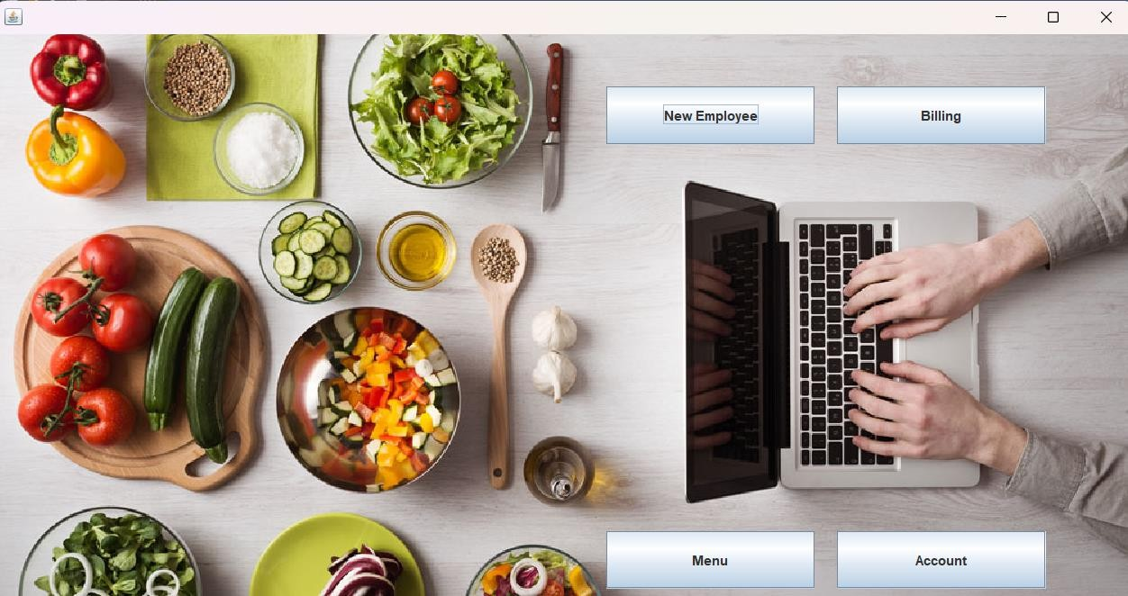

**New Employee:-**

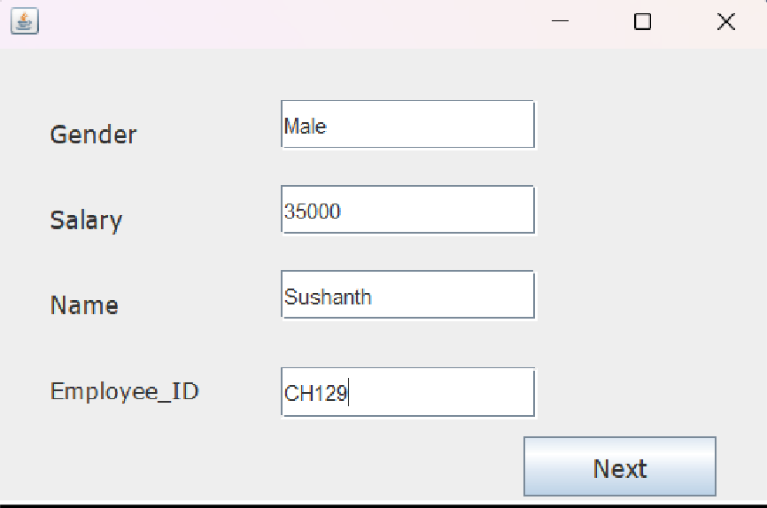

**Employee Display: -**

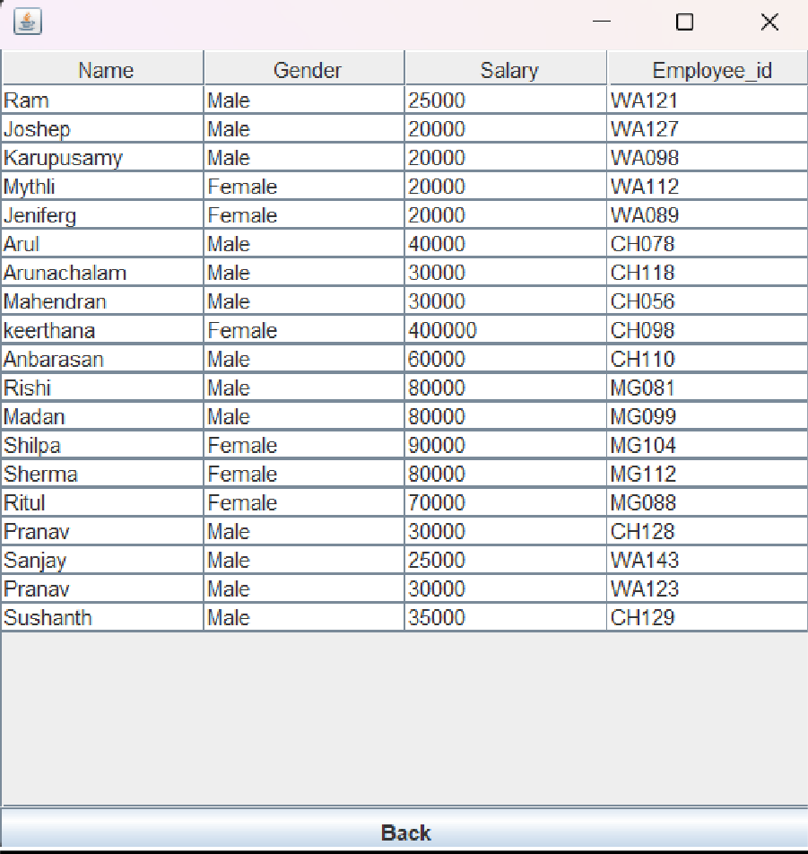

**Billing:-**

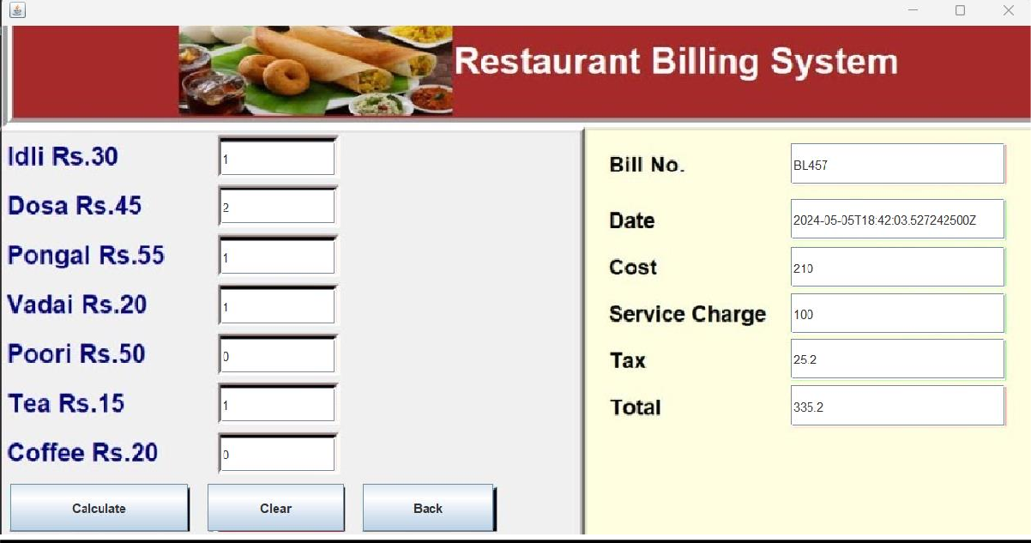

**Menu:-**

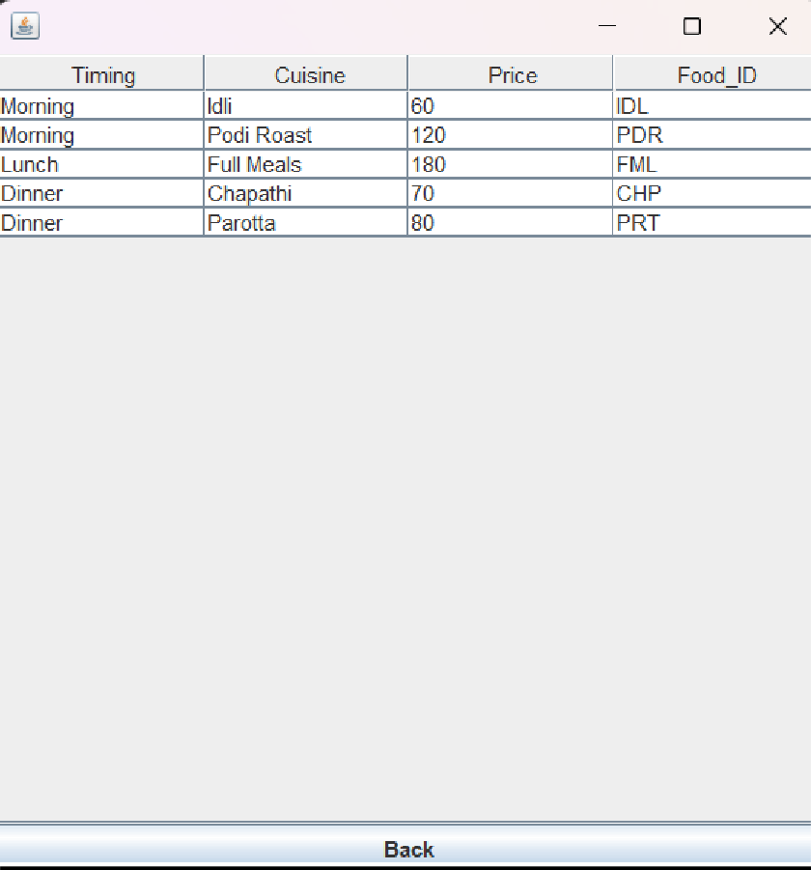

**Account Display:-**

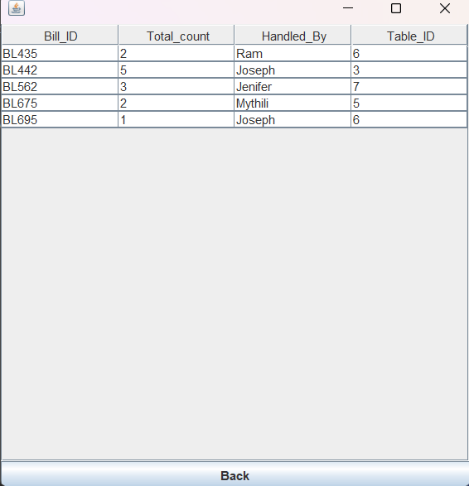

**FUTURE SCOPE AND LIMITATIONS**

Software developers may not expect. The following principles enhances extensibility like hide data structure, avoid traversing multiple.

Links or methods avoid case statements on object type and distinguish public and private operations.

* Reusability: Reusability is possible as and when require in this application. We can update it next version. Reusable software reduces design, coding and testing cost by amortizing effort

Over several designs. Reducing the amount of code also simplifies understanding, which increases the likelihood that the code is correct. We follow up both types of reusability:

Sharing of newly written code within a project and reuse of previously written code on new projects.

* Understand ability: A method is understandable if someone other than the creator of the method can understand the code (as well as the creator after a time lapse). We use the method, which small and coherent helps to accomplish this.
* Cost-effectiveness: Its cost is under the budget and make within given time period. It is desirable to aim for a system with a minimum cost subject to the condition that it must satisfy the entire requirement. Scope of this document is to put down the requirements, clearly identifying the information needed by the user, the source of the information and outputs expected from the system.

### LIMITATIONS:-

* + This application cannot be accessed remotely.
  + This application requires knowledgeable person to use this application.
  + This application does not have journals

**CONCLUSION**

After all the hard work is done for the Restaurant Management System, it is a software designed to streamline restaurant operations, including managing billing cycles, paying bills, and overseeing various operational details. This software significantly reduces the need for manual data entry, leading to greater efficiency in restaurant management. Its user-friendly interface makes it easy for anyone to use, thereby decreasing the time required for administrative tasks and enhancing overall productivity.

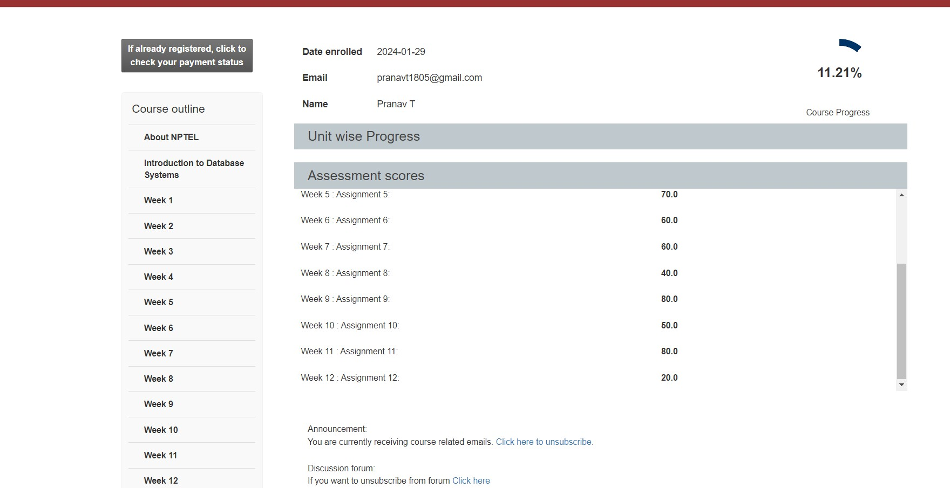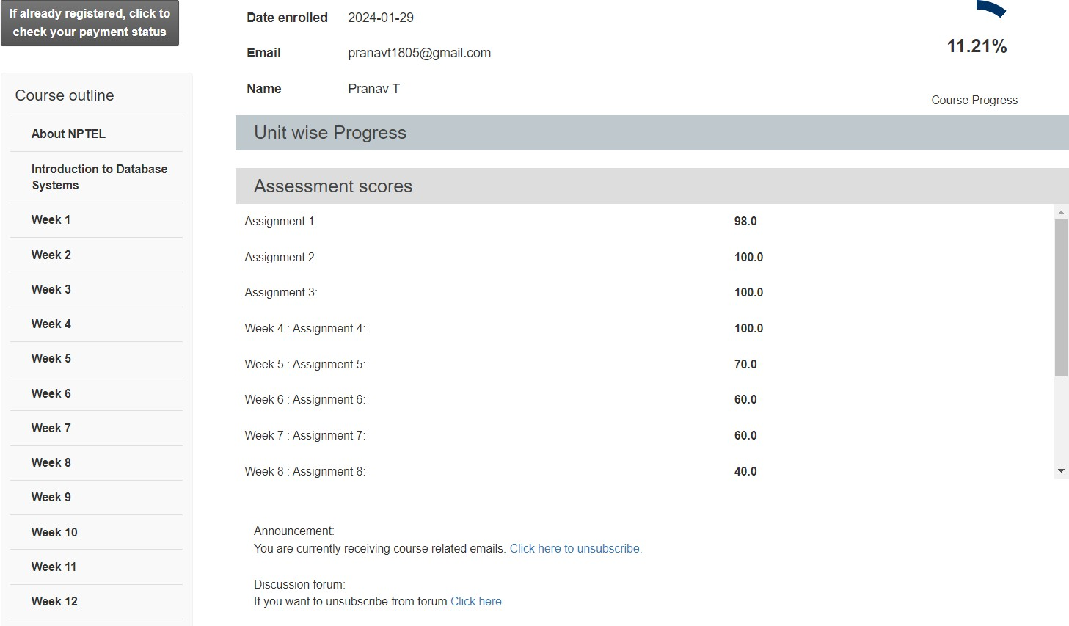

NPTEL

(Signature of Candidate)

|  |  |  |
| --- | --- | --- |
| MORIG SESSIO (Ï) | National Programme on Technology Enhanced Learning |  |
| Hall Ticket For | 2024 Apr: CS55 Introduction to Database Systems - Online |

|  |  |  |  |  |  |  |  |  |  |  |  |
| --- | --- | --- | --- | --- | --- | --- | --- | --- | --- | --- | --- |
| Candidate Name | Pranav T | | | | | | | | | |  |
| Roll No | NOC24CS55S553400299 | | | | | Seating Number | | | 53400299 | |
| Date of Birth | 18-05-2005 | | | | | | | | | |
| PwD Status | No | Compensatory Time Required | | | N.A | | Scribe Required | | | N.A |
| Exam Date | Sunday, 21 April, 2024 | | | | | | | | | |
| Reporting Time | 08:00 am | | | Gate Closure | | | | 09:30 am | | |
| Exam Timing | 09:00 am | | | Shift | | | | FN | | |
| Test Centre Name | iON Digital Zone iDZ Kovilambakkam | | | | | | | | | |  |
| Test Centre Address | Fortune Towers,1st and 2nd Floor,SH 109, 200 Feet Thoraipakkam Pallavaram Radial Road, Near Eachangadu signal,Kovilambakkam, Chennai, Tamil Nadu, India - 600117 | | | | | | | | | |
| **NPTEL Coordinator** | | |  | | | | | | | | |

|  |
| --- |
| **NPTEL EXAM - 21 APRIL, 2024**  **General instructions for candidates - FN**  (All timings mentioned here are in IST) |
| **The total duration of the examination is 180 minutes.**  **Candidates will be permitted to leave the examination hall only after 10:30 am, on a need basis.** |
| **Hall ticket and Entry:**   1. The Hall Ticket must be presented for verification along with one original photo identification (not photocopy or scanned copy). Examples of acceptable photo identification documents are School ID, College ID, Employee ID, Driving License, Passport, PAN card, Voter ID, and Aadhaar-ID. A printed copy of the hall ticket and original photo ID card should be brought to the exam centre. Hall ticket and ID card copies on the phone will not be permitted. 2. This Hall Ticket is valid only if the candidate’s photograph and signature images are legible. To ensure this, print the Hall Ticket on A4-sized paper using a laser printer, preferably a color photo printer. 3. **TIMELINE:** 8:00 am - Report to the examination venue | 8:40 am – Candidates will be permitted to occupy their allotted seats| 8:50 am – Candidates can login and start reading instructions prior to the examination | 9:00 am - Exam starts |   9:30 am - Gate closes, candidates will not be allowed after this time | 10:30 am Submit button will be enabled | 12:00 pm exam ends.   1. Candidates will be permitted to appear for the examination ONLY after their credentials are verified by center officials.   **P.T.O.** |

1. Candidates are advised to locate the examination center at least a day prior to the examination, so that they can reach the center on time for the examination.

**STATIONERY REQUIREMENTS:**

* + A4 sheets will be provided to candidates for rough work. Candidates have to write their name and registration number on the A4 Sheets before they start using it. The A4 sheets must be returned to the invigilator at the end of the examination.
  + On-screen calculator will be available during the exam. Candidates are advised to familiarize themselves with this virtual Scientific calculator well ahead of the exam.

Link: [https://www.tcsion.com/OnlineAssessment/ScientificCalculator/Calculator.html](http://www.tcsion.com/OnlineAssessment/ScientificCalculator/Calculator.html)

* + You should bring your own pen/pencil; it will NOT be given at the examination centre.

**DRESS CODE:**

* + Candidates are expected to come in professional attire to write the exams.
  + Candidates wearing SHORTS will NOT be permitted inside the exam hall.

**PERMITTED:**

* + You may bring vehicle keys inside the exam hall.
  + You are advised to carry your own drinking water in a transparent bottle.
  + Candidates are allowed to bring sanitizer in a small transparent bottle.

**NOT PERMITTED:**

* + Watches, wallets, mobile phones, Bluetooth devices, microphones, pagers, health bands or any other electronic gadgets, any printed/blank/handwritten paper, log tables, writing pads, scales, geometry/pencil-boxes, pouches, calculators, pen drives, electronic pens, handbags, goggles, electronic vehicle keys or similar such items are NOT allowed inside the examination centre. There may not be any facility for the safekeeping of these devices outside the examination hall; it will be prudent not to bring valuables to the examination center. Candidates will not be permitted to carry any food items in the exam centre. We suggest that you bring a bag to keep routine belongings outside the exam hall. Neither NPTEL nor the exam provider takes responsibility for the bag and the belongings. You may keep it outside at your own risk.

**MANDATORY :**

* + Hall tickets have to be returned to the invigilator before leaving the exam hall. No paper can be taken out of the exam hall.
  + Press the SUBMIT button on the computer after you have completed the exam.

**IMPORTANT:**

* + A basic code of conduct during the exam should be followed, failing which, NPTEL reserves the right to take appropriate action.
  + In case the exam is delayed due to any unforeseen circumstances, NPTEL will decide on the appropriate course of action as it deems fit.

**AT THE EXAM CENTRE, IF YOU ENCOUNTER ANY ISSUES WITH RESPECT TO THE COMPUTER OR EXAM OFFICIALS, KINDLY CONTACT THE NPTEL EXAM REPRESENTATIVE, WHO WILL BE AVAILABLE AT THE CENTRE.**

I HEREBY ACKNOWLEDGE THAT I HAVE READ, UNDERSTOOD AND AGREE TO FOLLOW THE ABOVE MENTIONED INSTRUCTIONS.

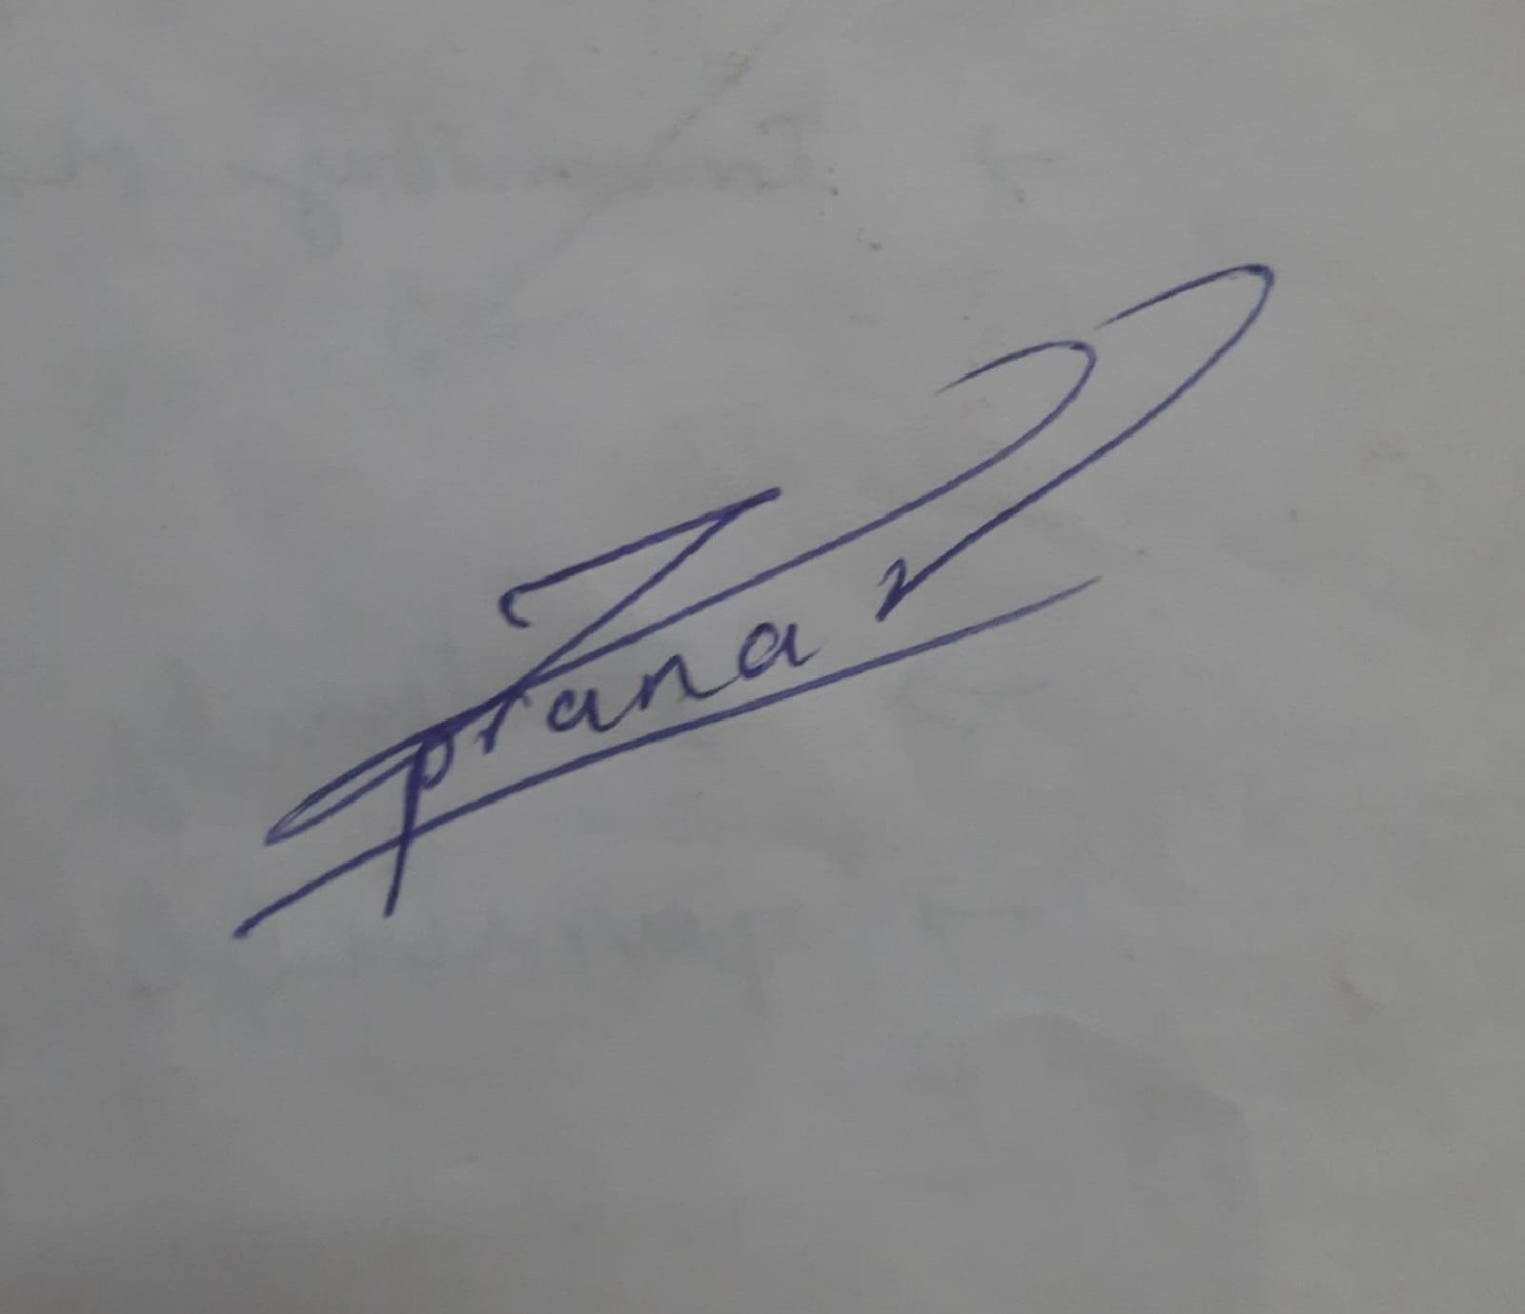

**Signature of the Candidate**

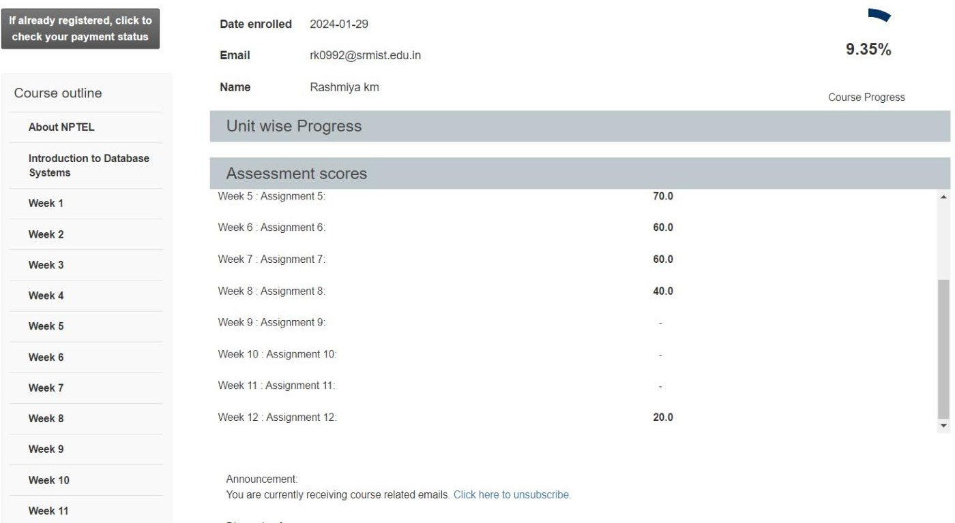

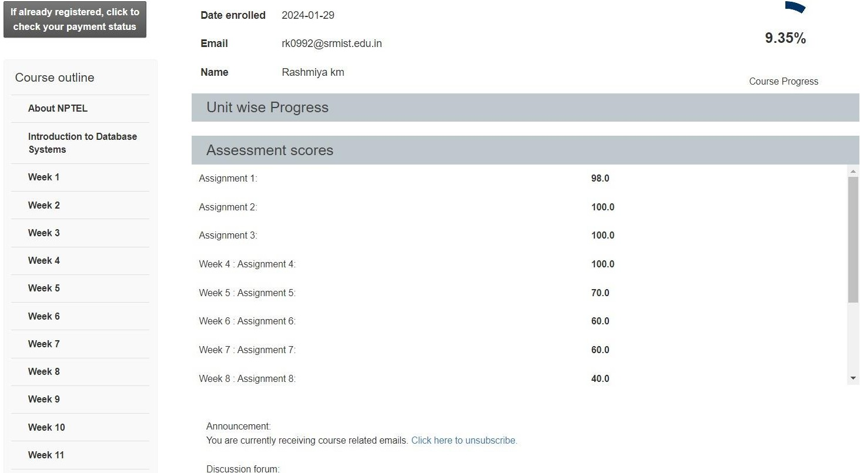

NPTEL

(Signature of Candidate)

|  |  |  |
| --- | --- | --- |
| 6ÏTEROO SESSIO  (6) | National Programme on Technology Enhanced Learning |  |
| Hall Ticket For | 2024 Apr: CS55 Introduction to Database Systems - Online |

|  |  |  |  |  |  |  |  |  |  |  |  |
| --- | --- | --- | --- | --- | --- | --- | --- | --- | --- | --- | --- |
| Candidate Name | Rashmiya km | | | | | | | | | |  |
| Roll No | NOC24CS55S653405019 | | | | | Seating Number | | | 53405019 | |
| Date of Birth | 30-03-2005 | | | | | | | | | |
| PwD Status | No | Compensatory Time Required | | | N.A | | Scribe Required | | | N.A |
| Exam Date | Sunday, 21 April, 2024 | | | | | | | | | |
| Reporting Time | 01:00 pm | | | Gate Closure | | | | 02:30 pm | | |
| Exam Timing | 02:00 pm | | | Shift | | | | AN | | |
| Test Centre Name | Sri Sai Ram Engineering College | | | | | | | | | |  |
| Test Centre Address | Sai Leo Nagar, Sairam Rd, West Tambaram, , Chennai, Tamil Nadu, India - 600044 | | | | | | | | | |
| **NPTEL Coordinator** | | |  | | | | | | | | |

|  |
| --- |
| **NPTEL EXAM - 21 APRIL, 2024**  **General instructions for candidates - AN**  (All timings mentioned here are in IST) |
| **The total duration of the examination is 180 minutes.**  **Candidates will be permitted to leave the examination hall only after 03:30 pm, on a need basis.** |
| **Hall ticket and Entry:**   1. The Hall Ticket must be presented for verification along with one original photo identification (not photocopy or scanned copy). Examples of acceptable photo identification documents are School ID, College ID, Employee ID, Driving License, Passport, PAN card, Voter ID, and Aadhaar-ID. A printed copy of the hall ticket and original photo ID card should be brought to the exam centre. Hall ticket and ID card copies on the phone will not be permitted. 2. This Hall Ticket is valid only if the candidate’s photograph and signature images are legible. To ensure this, print the Hall Ticket on A4-sized paper using a laser printer, preferably a color photo printer. 3. **TIMELINE:** 1:00 pm - Report to the examination venue | 1:40 pm – Candidates will be permitted to occupy their allotted seats| 1:50 pm – Candidates can login and start reading instructions prior to the examination | 2:00 pm - Exam starts |   2:30 pm - Gate closes, candidates will not be allowed after this time | 3:30 pm Submit button will be enabled | 5:00 pm exam ends.   1. Candidates will be permitted to appear for the examination ONLY after their credentials are verified by center officials.   **P.T.O.** |

1. Candidates are advised to locate the examination center at least a day prior to the examination, so that they can reach the center on time for the examination.

**STATIONERY REQUIREMENTS:**

* + A4 sheets will be provided to candidates for rough work. Candidates have to write their name and registration number on the A4 Sheets before they start using it. The A4 sheets must be returned to the invigilator at the end of the examination.
  + On-screen calculator will be available during the exam. Candidates are advised to familiarize themselves with this virtual Scientific calculator well ahead of the exam.

Link: [https://www.tcsion.com/OnlineAssessment/ScientificCalculator/Calculator.html](http://www.tcsion.com/OnlineAssessment/ScientificCalculator/Calculator.html)

* + You should bring your own pen/pencil; it will NOT be given at the examination centre.

**DRESS CODE:**

* + Candidates are expected to come in professional attire to write the exams.
  + Candidates wearing SHORTS will NOT be permitted inside the exam hall.

**PERMITTED:**

* + You may bring vehicle keys inside the exam hall.
  + You are advised to carry your own drinking water in a transparent bottle.
  + Candidates are allowed to bring sanitizer in a small transparent bottle.

**NOT PERMITTED:**

* + Watches, wallets, mobile phones, Bluetooth devices, microphones, pagers, health bands or any other electronic gadgets, any printed/blank/handwritten paper, log tables, writing pads, scales, geometry/pencil-boxes, pouches, calculators, pen drives, electronic pens, handbags, goggles, electronic vehicle keys or similar such items are NOT allowed inside the examination centre. There may not be any facility for the safekeeping of these devices outside the examination hall; it will be prudent not to bring valuables to the examination center. Candidates will not be permitted to carry any food items in the exam centre. We suggest that you bring a bag to keep routine belongings outside the exam hall. Neither NPTEL nor the exam provider takes responsibility for the bag and the belongings. You may keep it outside at your own risk.

**MANDATORY :**

* + Hall tickets have to be returned to the invigilator before leaving the exam hall. No paper can be taken out of the exam hall.
  + Press the SUBMIT button on the computer after you have completed the exam.

**IMPORTANT:**

* + A basic code of conduct during the exam should be followed, failing which, NPTEL reserves the right to take appropriate action.
  + In case the exam is delayed due to any unforeseen circumstances, NPTEL will decide on the appropriate course of action as it deems fit.

**AT THE EXAM CENTRE, IF YOU ENCOUNTER ANY ISSUES WITH RESPECT TO THE COMPUTER OR EXAM OFFICIALS, KINDLY CONTACT THE NPTEL EXAM REPRESENTATIVE, WHO WILL BE AVAILABLE AT THE CENTRE.**

I HEREBY ACKNOWLEDGE THAT I HAVE READ, UNDERSTOOD AND AGREE TO FOLLOW THE ABOVE MENTIONED INSTRUCTIONS.

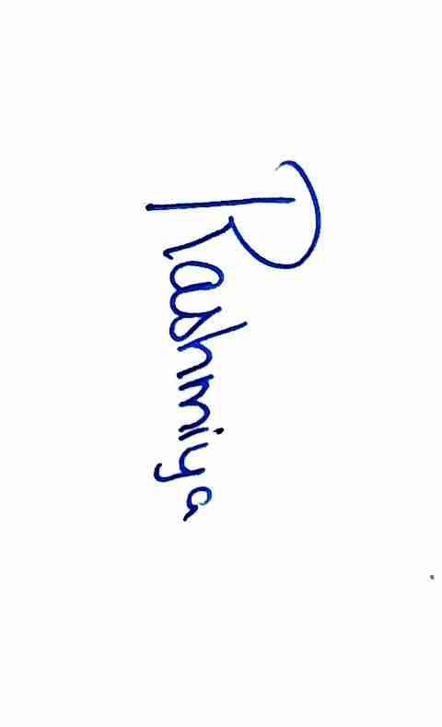

**Signature of the Candidate**